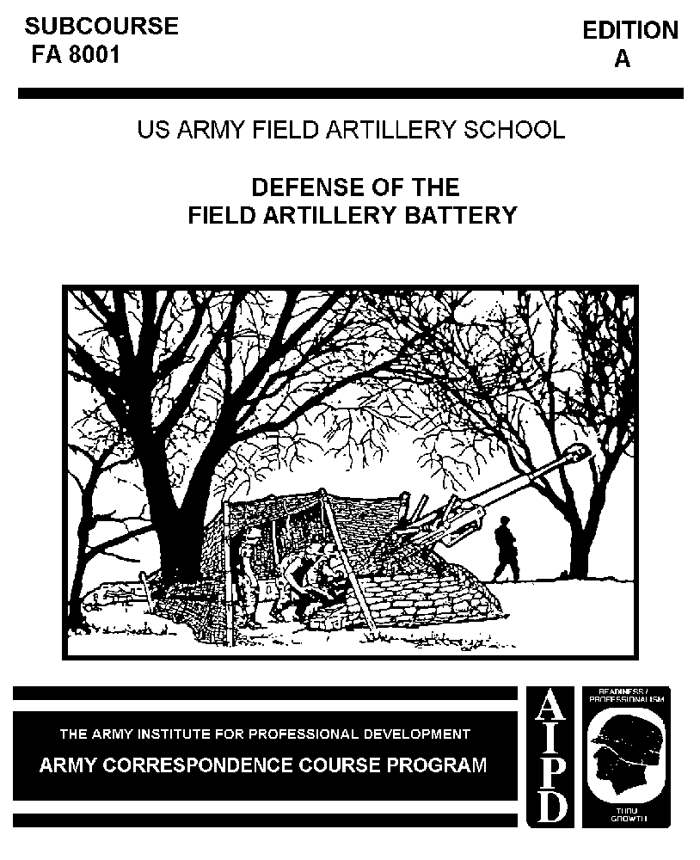
TABLE OF CONTENTS

Table of Contents

Subcourse Overview

Lesson 1: Fundamentals of Unit Defense

Part A - Threat Capabilities and Battery Responsibilities

Part B - Considerations for Defense

Part C - The Defense Diagram

Part D - Communications in the defense

Summary

Practice Exercise

Answer Key and Feedback

Lesson 2: Conduct of the Defense

Part A - Responding to Enemy Attack

Part B - Evaluating the Defensive Posture

Summary

Practice Exercise

Lesson 3: Camouflage Principles and Techniques

Part A - Principles of Concealment

Part B - Individual Camouflage

Part C - Camouflage of Section Positions and Equipment

Part D - Reducing Artillery Revealing Factors

Summary

Practice Exercise

Answer Key and Feedback

Lesson 4: Field Fortifications

Part A - Types of Emplacements

Part B - Fields of Fire

Summary

Practice exercise

Answer Key and Feedback

Appendix A - Practice exercise Paraphernalia

Appendix B - Extract, FM 6-50, Appendices F and H

Appendix C - Sensors and Night Observation Devices

Examination

DEFENSE OF THE FIELD ARTILLERY BATTERY

Subcourse FA 8001

EDITION A

United States Army Field Artillery School
Fort Sill, Oklahoma 73503

Edition Date: January 1992

Credit hours: 5.

SUBCOURSE OVERVIEW

This subcourse teaches how to develop a field artillery battery or platoon defense plan; identify characteristics of a successful defense plan; and select the appropriate defensive course of action based upon tactical scenario.

Prerequisites: FA 8000, Field Artillery Battery RSOP, Advance Party Security Sweep, and Marches.

This subcourse reflects the doctrine, which was current at the time it was prepared. In your own work situation, always refer to the latest official publications.

Unless otherwise stated, the masculine gender of singular pronouns is used to refer to both men and women.

TERMINAL LEARNING OBJECTIVE

ACTION: Direct the defense of a field artillery unit.

CONDITION: Given the material contained in this lesson.

STANDARD: To demonstrate competency in this task, you must achieve a minimum of 70% on the subcourse examination.

LESSON 1

FUNDAMENTALS OF UNIT DEFENSE

Critical Task: 01-2660.01-0052
061-266-4016

OVERVIEW

LESSON DESCRIPTION

In this lesson you will learn general threat capabilities to detect and destroy friendly field artillery assets. However, you will also learn techniques to avoid enemy detection and how to establish a viable defense plan.

TERMINAL LEARNING OBJECTIVE

ACTION: Establish the plan for the defense.

CONDITION: Given the material contained in this lesson.

STANDARD: Correctly answer all questions in the practice exercise at the end of this lesson.

References: This lesson is based on FM 6-50, The Field Artillery Cannon Battery, and other materials approved for US Army Field Artillery School instruction. However, development and progress render the text continually subject to change. Therefore, base your examination answers on material presented in this text rather than on individual or unit experience.

INTRODUCTION

The field artillery cannon battery is the basic firing element of the cannon battalion regardless whether the battery has a battery-based (3 batteries per battalion, 6 howitzers or 3x6) or platoon-based (3 batteries per battalion, 8 howitzers or 3x8)organization. In no way should the references to platoon-based or battery-based organization be construed as the structure for operational employment. Rather, the terms pertain solely to organizational structure. Regardless of the organization, however, the enemy will attempt to neutralize, or destroy field artillery units. Further, they will bring to bear their most modern technology to accomplish that. Therefore, all field artillerymen must know and apply passive and active defense measures against artillery, air and ground attacks if they are to survive and provide continuous support.

PART A - THREAT CAPABILITIES AND BATTERY RESPONSIBILITIES

1. Detection Capabilities.

The enemy will try to detect FA elements through the study of our doctrine and the collection of signals intelligence (SIGINT), imagery intelligence (IMINT), and human intelligence (HUMINT).

a. Signals Intelligence.

(1) Using signal intercept and radio direction finding (RDF) equipment, the enemy collects various frequency modulated (FM) and amplitude modulated (AM) radio transmissions. Through triangulation, the enemy fixes the signal. About 25 seconds after communications begin, the enemy can begin his targeting sequence. The enemy targeting sequence can continue even if our communications stop. Within 2 to 3 minutes, the information can produce a jamming mission, a fire mission or a combat mission. Enemy RDF units at distances in excess of 10 kilometers can pick up tactical FM radios operating on low power. High-power signals can be detected at distances up to 40 kilometers. However, directional antennas and reduced radio use will improve survivability.

(2) Other targeting means are radars, sound, and visual target detection teams. Radars can detect firing weapons to a 75-150 meter accuracy, but they depend on survey and the weapon trajectory. Higher trajectories produce more accurate results. Seismic and sound ranging can locate targets within 150 meters. However, their accuracy is diminished by other battle noise, and they are affected by weather and the soil. Unaided visual observations depend on line of sight, and their accuracy varies. Visual, sound, and radar collectors are commonly organic to the frontline units; and immediate targeting can be expected. RDF accounts for 10 percent of enemy detection of friendly artillery; sound and flash provide about 70 percent; while radar and visual assets provide the remaining 20 percent.

b. Imagery Intelligence. This effort is normally coordinated and is cued by other sensors. It consists of photographic imagery, thermal detection, radar location, and laser imagery. The product from these sensors requires laboratory processing. Normally, a lab is not organic to the frontline units, and data must be transcribed to a map sheet during the analysis. Unless assigned as a special mission, the processing of IMINT requires 6 to 8 hours. Target location error (TLE) from IMINT is currently 200 meters.

c. Human Intelligence. Long-range patrols, spies, partisans, and enemy prisoners of war (EPWs) are the HUMINT collectors. Although HUMINT relies primarily on visual observation, the peculiar equipment, predicted activities, bumper markings, spoils of war and rubbish that is left behind add to the accuracy of the targeting effort.

2. Attack Capabilities. Threat forces can suppress or destroy a battery by the following techniques:

- Counterfire. Enemy attacks with upward of 600 rounds fired into a 200 X 100-meter (m) area.

- Air attack. This includes high-performance aircraft and helicopters.

- Ground forces. This includes mounted forces of tanks and motorized infantry; dismounted forces of infantry, airborne and air assault forces; and partisans and guerrillas.

- Radio electronic combat (REC). REC combines SIGINT, direction finding, intensive jamming, deception, and destructive fires to attack enemy organizations and systems.

3. Detection and Attack Capabilities Under Development.

The Soviet Union continues to improve their old field artillery detection and attack systems and to develop new ones. Client states and 3rd world countries will likely benefit from this technology through Soviet arms sales. Listed below are Soviet target detection and attack systems that will challenge U.S. field artillery survivability on the future battlefield.

a. Counterbattery (CB) radars. The Soviets are developing and deploying radars to cover both static and high mobility weapon systems. CB radars currently have a range of 20 km with nominal target location error (TLE) of 75-100 meters. Fifty meter TLE is expected with phased array radars.

b. Moving target imagery (MTI) radars. In the future, MTI radars may be a greater threat than the counterbattery radars since the Howitzer Improvement Program (HIP) howitzer moves frequently. The Soviets can be expected to continue improving their MTI radars. Currently, SMALL FRED (MTI) radars have a range of 20 km and TLE of under 50 meters.

c. Command and control (C2) technology. Soviet forces will continue developing automated tactical and technical fire direction systems that will improve the speed with which multiple targets can be attacked. Although they now have a crude version of an automated artillery command and control system, its results are checked by manual computations, which cancels the speed advantages of automation.

d. Artillery delivered mines. The threat will look for ways to limit the movement of U.S. systems within the position area. This will be done by an extensive use of artillery delivered mines.

e. Unmanned aerial vehicles. Reconnaissance drones for television imagery and photographic intelligence.

f. Electronic support measures. Electronic support measures are interception and direction-finding of emitted electronic signals from either communications or non-communications sources. While the Soviet capabilities in the area of intercept and direction-finding are not new, they can be expected to get better in the future.

4. Battery Responsibilities.

a. The BC or platoon leader is responsible for general planning, coordination, and execution of the defense of his battery or platoon and for establishing defensive priorities. (Appendix B, an extract of Appendix H, FM 6-50, provides sample checklists to help leaders go through a mental review of existing battery or platoon defensive preparations).

b. The first sergeant integrates the platoon defense plans into an overall battery defense plan.

c. As an example, the platoon sergeant may do the following tasks depending on his unit's mission, or the battery or battalion SOP:

- Develop the platoon defense plan (PART C, this lesson).

- Rehearse defense forces.

- Determine the final locations for the following:

-- Crew-served weapons.

-- Antitank weapons.

-- Observation posts (OPs) and listening posts (LPs).

- Ensure that communications are installed, checked, and functioning.

- Organize the reaction force

- Ensure that unit members know equipment and destruction procedures.

d. The section chief does the following:

- Ensures that the howitzer range card is prepared (PART C, this lesson).

- Studies the routes to and locations of alternate and supplementary positions.

- Ensures that the crew-served weapons range cards are prepared (PART C, this lesson).

- Ensures that individual and crew-served fighting positions are properly prepared and have adequate overhead cover (Lesson 3).

e. All battery leaders become familiar with the defense plan and brief their subordinates on its execution.

PART B - CONSIDERATIONS FOR DEFENSE

1. Use of Terrain

Two major considerations in planning to use terrain are camouflage and fortifications. The terrain that you are given to defend will determine the time and energy needed to construct an adequate defense. Camouflage and fortification techniques will be dealt with in Lesson 3 and Lesson 4. The following paragraphs will explain camouflage and fortifications as concepts to be considered in defense planning.

a. Camouflage. A battery that is concealed from enemy detection has greatly increased its chances of survival. This is because, on the modern battlefield; if it can be seen it will be hit--if it can be hit, it can be killed.

(1) To avoid this chain of events, soldiers must understand the six factors of recognition: position, color, shape, shadow, texture, and movement.
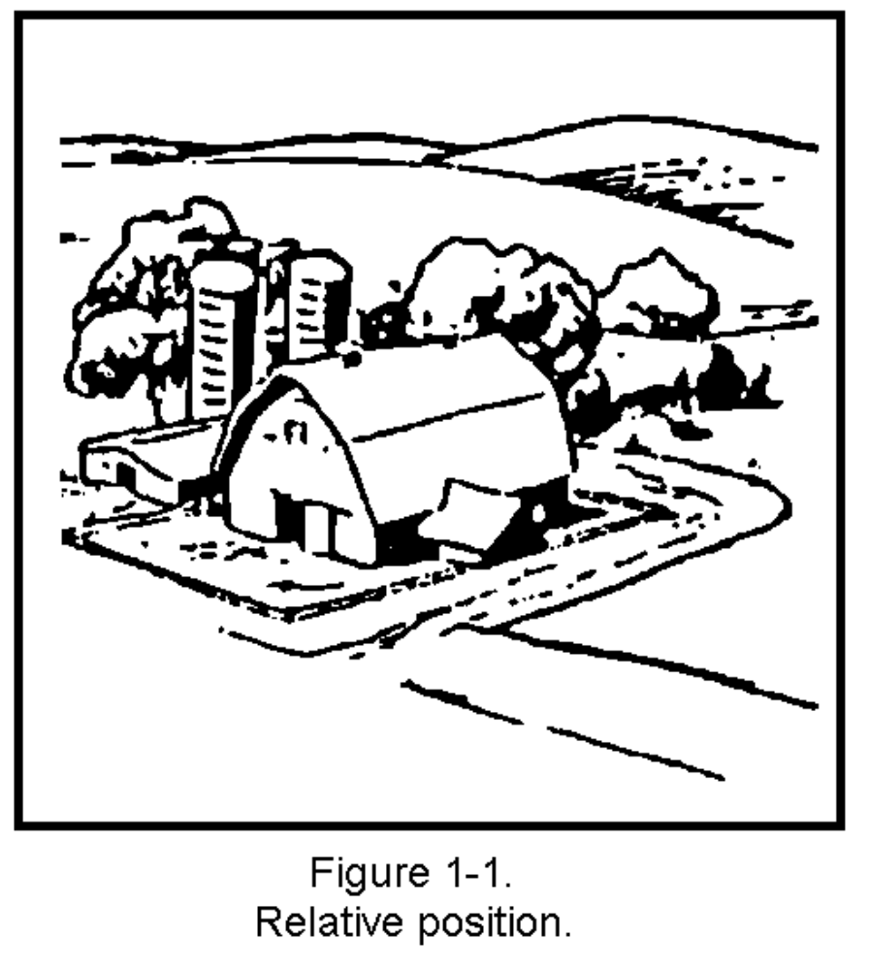
- Position. Relative position (Figure 1-1) refers to the relationship of an object or person to its surroundings or background. Certain things belong in certain places. When things are out of place, they become conspicuous, and the enemy becomes suspicious. This is because we identify objects in relation to their surroundings. For example, a long object on a railroad track is assumed to be a train; similar objects on a river and parallel to its banks are assumed to be boats or barges. A large building surrounded by several small buildings in a rural setting is probably a barn, but the same structure by itself attracts immediate attention. Position is nothing more than the relative space relationship of one object to another object or objects. Making things look like they belong is called siting.

- Shape. Observers learn the shape of many objects through experience. The outline of most items of military equipment (Figure 1-2), such as trucks, guns, tanks, and the steel helmet, are very distinctive and enable an observer to identify it long before he is close enough to recognize details.
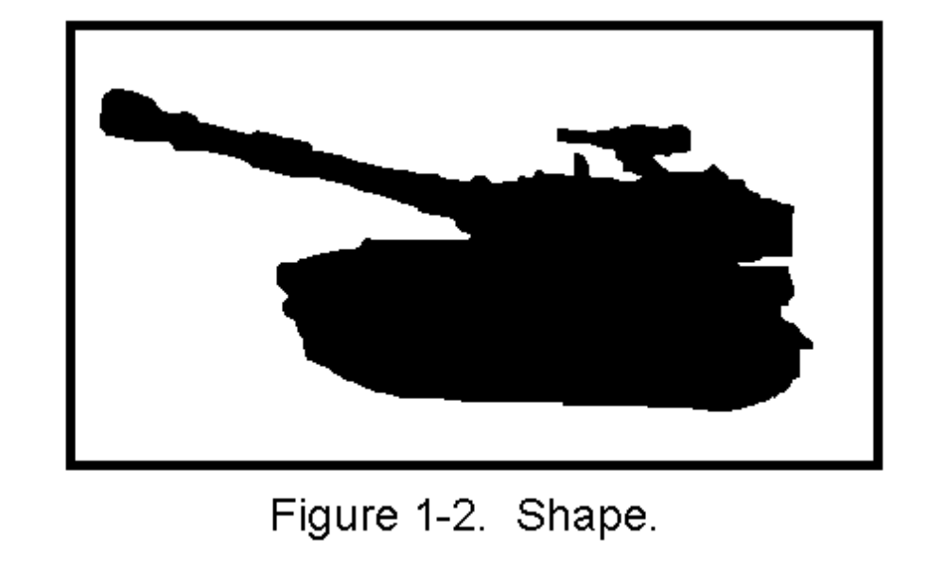

- Shadow. Shadow (Figure 1-3) may be even more revealing than the object itself, particularly when viewed from the air or seen on an aerial photograph. Factory chimneys, vehicles, bridges, and tents have distinctive shadows. Conversely, shadows sometimes may assist in concealment. Objects in the shadow of another object are more likely to be overlooked. It is therefore very important to break up, disrupt, or obliterate the shadow of military equipment. | 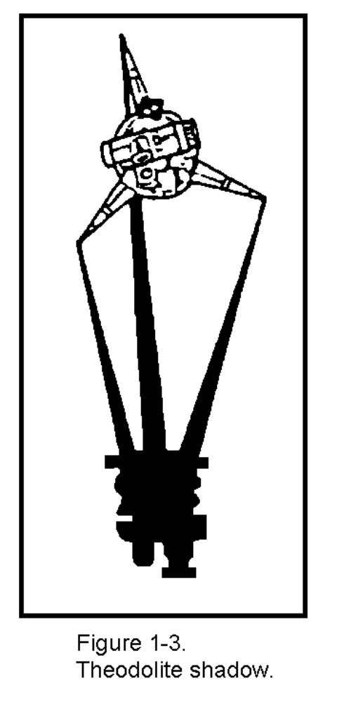

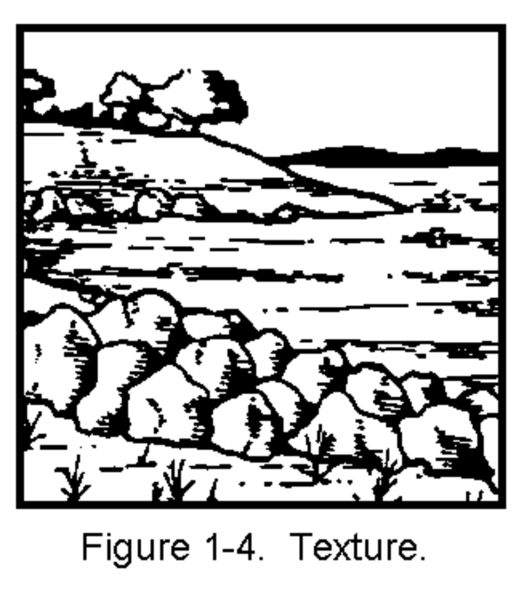 | - Texture. The relative smoothness or roughness of a surface and its ability to reflect, absorb, and diffuse light is called texture (Figure 1-4). A field of grass reflects little light and casts many shadows. Consequently, it appears very dark to the eye or on a photograph. A smooth surface reflects light and produces shine. Shine attracts the attention of any observer in almost any situation Whenever light strikes a smooth surface, such as a windshield, a headlight, mess gear, or even a person's face, light is reflected directly into the observer's eye or the camera lens with striking emphasis.
- Color. Colors in nature are generally not brilliant. When there is contrast between the color of an object and its background, it becomes more visible to the observer. Color alone does not normally identify an object, but color aids in locating it and invites further observation. Another consideration is the tone hue of a color. Usually darker shades of a given color are less likely to attract attention than the lighter, more brilliant tones.

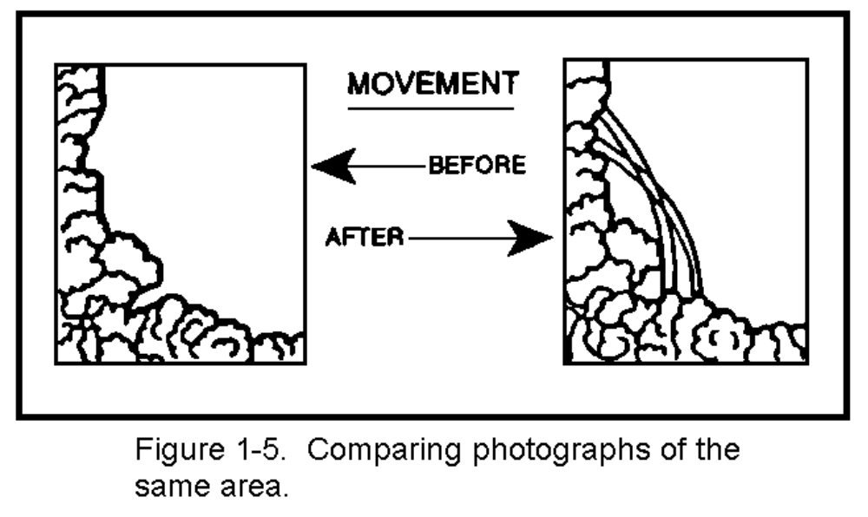
- Movement. Movement does not actually reveal the identity of an object but it does reveal the existence of an activity. When all other factors of recognition have been completely eliminated, a position can still be revealed to observers if movement is not controlled. Aerial cameras can reveal that something has moved when two photographs of the same area, taken at different times, are compared. If an object has moved, or if something has been added, such as tracks crossing a field (Figure 1-5), it can be very apparent.

b. Light and Noise discipline. Following are some tips on camouflage construction and light and noise discipline.

o Use artificial camouflage. Two artificial camouflage measures that can reduce the chance of recognition are pattern painting of equipment with the NATO three-color patterns and proper use of the lightweight screening system (LWSS). LWSS can provide complete concealment from direct observation, especially when supplemented with natural materials. However, as with most artificial camouflage materials, it can frequently be detected by photographic observation if it fails to blend properly with the background. Nevertheless, when properly suspended and supported, the LWSS conceals the identity of a vehicle or activity.

- Properly site electronic equipment to reduce signatures, and position all battery equipment to eliminate exposure and detection.

- Make use of all camouflage. Trees and shrubs can hide a battery or platoon. Built-up areas are great for hiding equipment, because man-made items look like other manmade items and do not contrast with natural surroundings.

- Use whatever terrain and natural concealment available to blend into the surroundings.

- Maintain light and noise discipline.

- Use the track plan. As explained above, the most common signs of military activities in an otherwise well camouflaged area are tracks, spoil (dirt residue from digging fighting positions), debris, and movement. The BC must enforce his track plan. Existing roads and trails must be used. If none are available, some should be created with heavy vehicles to give the appearance that a unit has moved through the area. The roads and trails must have logical starting and ending points.

2. Fortification.

Construction of fortifications is the second use of terrain that must be considered by leaders in planning for defense. Some of the things that should be remembered are:

a. Defensible terrain. Occupy positions that have natural advantages for defense, such as interior tree lines and ravines.

b. Position improvement. Harden battery positions and dig in whenever possible. FM 5-103 shows good examples of hardened positions.

c. Use of obstacles. Whenever possible, construct obstacles to delay, stop, divert, or canalize an attack force. All obstacles should be covered by fire. Types of man-made obstacles and techniques for their employment are in FM 5-103.

d. Individual fighting positions. In fast-moving situations or when emergency displacement is anticipated, hardening might be limited to digging fighting positions on the perimeter, burying wire, placing sandbags around sensitive equipment such as collimators and tires, and constructing individual shelters for prone personnel. If natural cover is limited or unavailable, individual fighting positions should be constructed. FM 7-7 gives instructions on how to construct fighting positions.

e. Spoil. Spoil is the residue left over from digging in equipment and individual fighting positions. This includes dirt thrown out of these positions. To complete the job of camouflaging a position, spoil must also be camouflaged.

3. Defense in Depth.

The defense plan is established to provide a flexible, all-around defense of the battery or platoon position area. Defense operations should be planned so that the BC and platoon leaders are warned of an impending attack soon enough to displace the unit or defend the position. OPs and LPs are key elements for early warning. How far from the battery area OPs and LPs are located depends on terrain, visibility, likely threats and how much time the battery requires to displace or occupy preselected fighting positions. Locate OPs to observe likely avenues of approach so the enemy can be engaged at long range with artillery, mortars, or close air support. Man OPs with at least a two-man team, and provide them with antitank weapons and communications. When determining the location of the OPs and/or the LPs, consider:

- observation and fields of fire.

- cover and concealment.

- key terrain.

- avenues of approach.

- METT-T.

4. Security.

The cannon battery or platoon is highly vulnerable to attack as it occupies or displaces from a position. The first order of business is establishing security.

a. Upon occupying a position, each section must have a predetermined sector of responsibility. It must make maximum use of primary weapons and ensure there is a coordinated all around defense with interlocking fires. The defense plan includes all weapons available internally or externally that can be brought to bear on an enemy. The defense plan is depicted by a defense diagram (PART C). The defense diagram is based on the data for each howitzer and each machine gun range card. It includes the fields of fire for grenade launchers, antitank weapons, and individual weapons. The diagram is prepared by the platoon sergeant and approved by the platoon leader. If howitzer sections are dispersed over great distances, each section becomes responsible for its defense. It must be able to defend itself in its defensive prepared positions until help arrives.

b. FM 6-50 states that should the platoon be attacked or penetrated by enemy forces, the unit's reaction force will respond. However, experience dictates that before this action is taken, the following important points must be considered.

(1) The reaction force must be well trained in infantry tactics. They must also be well trained as a unit and know exactly when and where to organize. Without an intensively trained reaction force, the enemy could destroy it before the force had a chance to function. Remember, the use of the reaction force is a last resort.

(2) Platoon-based batteries have a reduced capability to field a reaction force because of its organizational structure. This especially true in split battery operations. Consideration should be given to using organic, vehicle mounted weapons to stop a penetration if a well trained reaction force is not available.

(3) If a reaction force is to be formed, it is important that the general composition and actions of the reaction force be documented in the unit SOP. Moreover, the reaction force should have thorough rehearsals on battle drill, communications and other aspects of battle that will guarantee success. A suggested composition of the reaction force (based on FM 6-50) is as follows:

- Reaction force NCO in charge; for example, the platoon sergeant.

- One man per howitzer section. While this may appear to violate unit integrity, use of only one man per section allows the section to continue its mission even while the reaction force is operating.

- One man from the fire direction center or platoon operations center (POC).

- One man from the communications section (if available).

- One man from the maintenance section (if available and in position to assist).
NOTE: The exact composition of the reaction force must meet the needs of the units that use them. Battalion and higher SOPs should provide further guidance on their make-up.
5. Dispersion.

Dispersion minimizes the effects of an air attack or a counterfire attack. When using this technique, units should disperse, as a minimum, over a 200- by 400-meter area with howitzers no closer than 100 meters. The FDC should be positioned about 100 meters from either flank howitzer. Figure 1-6 shows a platoon position with elements not dispersed. Figure 1-7 shows a platoon position with elements dispersed. The dotted lines in both figures indicate the area normally covered by enemy counterfire. Remember that figures 1-6 and 1-7 are representations of distance only. They do not represent tactical placement of howitzers.

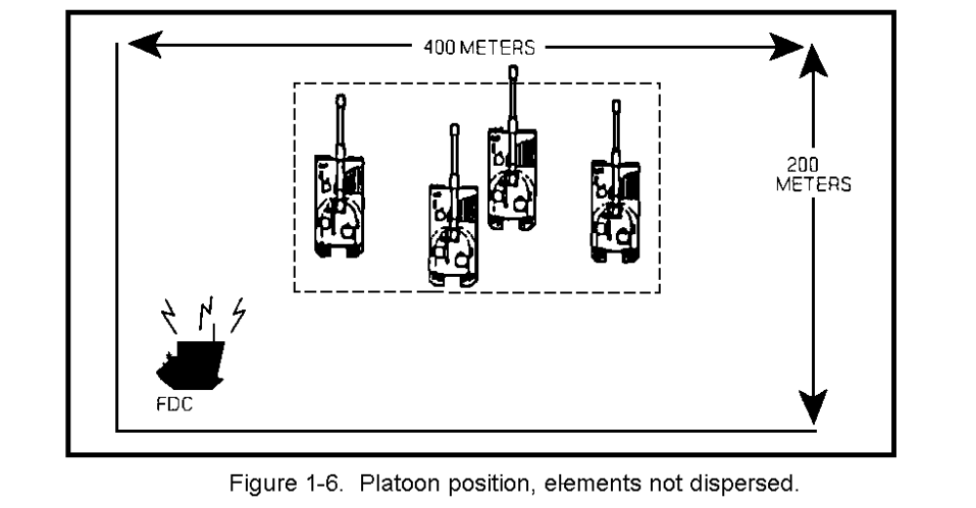
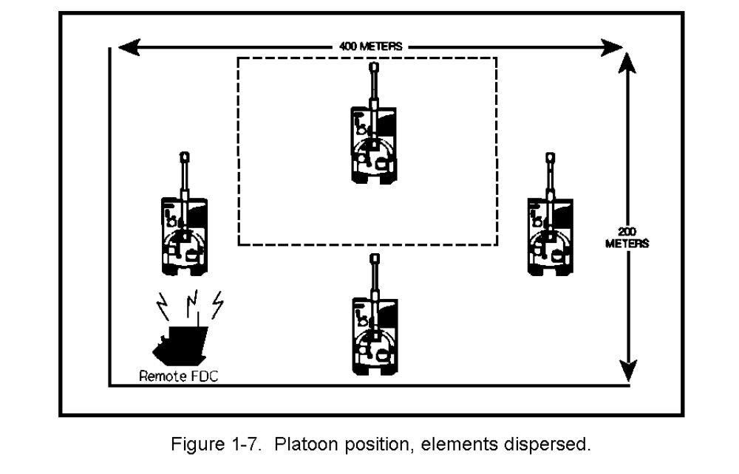
NOTE: With the use of the BCS and BUCS, howitzers can be accurately located over a widely dispersed area of operation. Platoon Operations Centers (POCs) will take on a more significant role as a control center for field artillery operations.

6. Priorities.

Priorities for the defense are highly dependent on many variables of situation, mission, and scheme of maneuver of the battery and platoon. Personnel and equipment available will also dictate priorities to some extent. However, there are some basic priorities that must be accomplished in any defense. The two most common situations--and priorities to meet them--are outlined in the paragraphs below.

a. Continue mission in position. The BC or platoon leader may be instructed to continue his mission in the position despite hostile counterfire. In that case, he might establish the following tasks in the priority indicated:

- Harden critical items of equipment.

- Prepare individual fighting positions.

- Prepare defensive positions.

- Select alternate positions, displacement routes, and signal in case movement is unavoidable. Brief key personnel on this information.

- Camouflage.

b. Displace on receiving fire. The BC or platoon leader may be instructed to displace upon receiving fire. In that case, he would have different priorities. For example, he might establish the following tasks to be done before receiving incoming fire:

- Camouflage.

- Prepare limited protection for personnel and equipment.

- Reconnoiter and/or select alternate positions, displacement routes, and march-order signal.

- Prepare alternate positions.

- Prepare defensive positions.

- Improve individual protection.

- Improve equipment protection.

c. Priority-of-work distribution. The duties of the section members may be different if they are ordered to continue the mission or to displace on receiving fire. Tables 1-1 and 1-2 are samples of duty assignments. Actual work priorities should be included in unit SOPs.
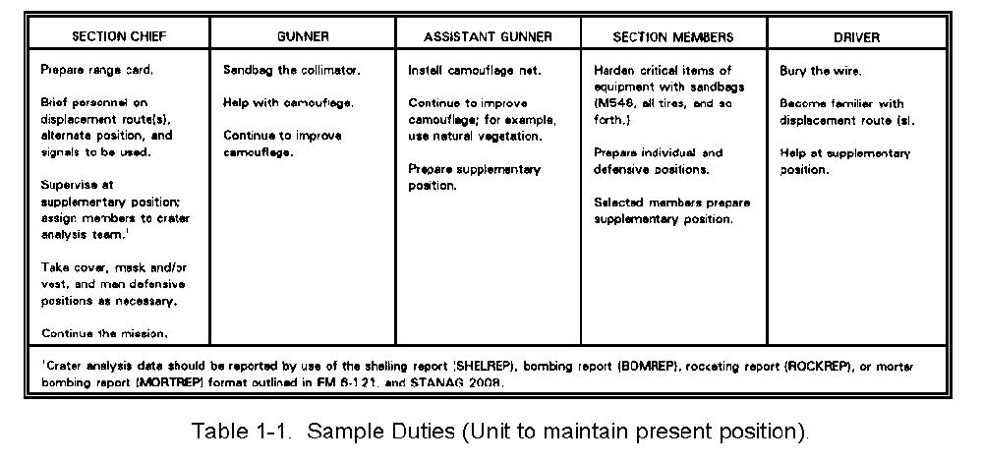
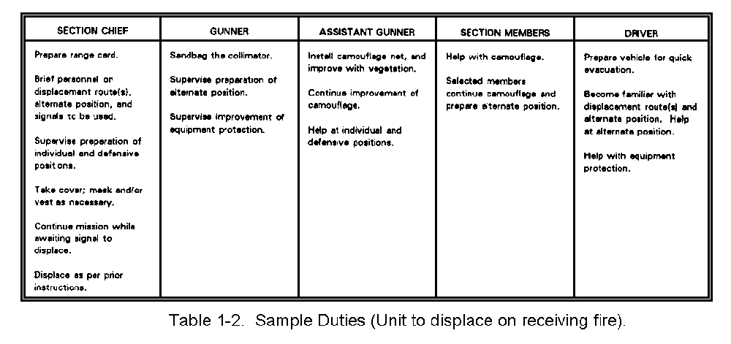
7. Defense in all directions.

The enemy may attack from any direction; so the platoons must be able to defend in all directions.

8. Mutual Support.

Mutual support means one unit helping another unit or one soldier helping another soldier. Fires from other platoons should be coordinated for defensive fires and attack of long-range targets. Within the platoon, one section must be ready to support another section. Apply the same concept to the individual soldier, and you can build a formidable defense. Range cards for crew-served weapons are essential to plan mutual support and insuring a good defense.

9. Control.

The BC and platoon leaders must control their personnel and firepower before, during, and after an attack so the correct actions can be taken at the right time. Battery and platoon SOPs must be developed so that everybody will know what to do.

10. Flexibility.

Unanticipated actions or incidents frequently occur which force a readjustment of any plan or routine. In fact, this tendency is so common in military operations that the great military philosopher, Clausewitz, named this tendency "friction". During training or combat, the BC and platoon leaders must be able to respond quickly to this friction. They must constantly evaluate METT-T and be prepared to deal with situations that are not in the plan.

PART C - DEFENSE DIAGRAM

The defense diagram graphically portrays the position area with respect to the azimuth of fire. This diagram shows the position area, all section positions, all defensive positions, and key terrain. It is a key visual aid to insure there is a defense plan, which provides 6,400-mil coverage for the battery. Also, this diagram is sent to battalion and is used to develop a battalion defensive fire support plan.

1. Constructing the Diagram.

The first step in constructing the defense diagram is determining the location of different points for the defense diagram and constructing the corresponding grid sheet. The BUCS or BCS can simplify the process of determining grid coordinates and the altitude of positions in and around the platoon or battery area. Computations are made by using the input piece location routine. TC 6-40A contains the steps for this routine.

a. Constructing the matrix. There are different methods of constructing a matrix on which to draw your diagram. The key is to pick a scale for easting and northing grid lines which will enable you to plot all or most of the desired locations. The FDC section has preprinted grid sheets, which are scaled to 1:25,000. Each grid square represents 1,000 meters on these sheets. Examples of the scale interval you could use are:

- 1:12,500--Each grid square represents 500 meters.
- 1:5,000--Each grid square represents 200 meters.

NOTE: To construct the defense diagram, use a 1:50,000 map of the area, a coordinate scale, a protractor, overlay paper, and a blank 1:25,000 grid sheet. (The map scale of the area need not be only 1:50,000. Any military grid map of at least this scale is satisfactory. The key is to subdivide each grid square into 200- by 200-meter squares, increasing the scale to 1:5,000.)

b. Constructing the diagram. There are seven steps involved in constructing the defense diagram.

- Isolate the defensive area.

- Construct the matrix.

- Reproduce key terrain.

- Plot key positions.

- Plot sectors of fire.

- Record related information.

(1) Isolate the defensive area. Isolate the platoon or battery position so that you can expand the key topographical information to a 1:5,000 scale.

(a) Locate the platoon center on the 1:50,000 map. Identify the grid square or squares that contain the terrain features that influence the defense of the platoon position.

(b) Place tick marks at 200-meter intervals along the sides of the selected grid squares (Figure 1-8).
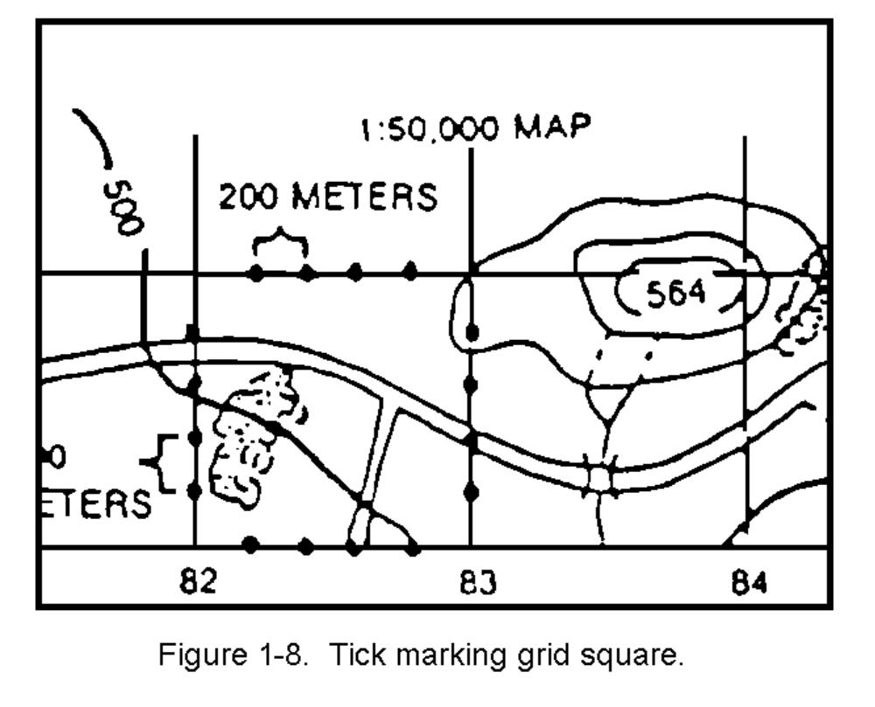
(c) Connect the tick marks to form 200- by 200-meter squares within each grid square (Figure 1-9).
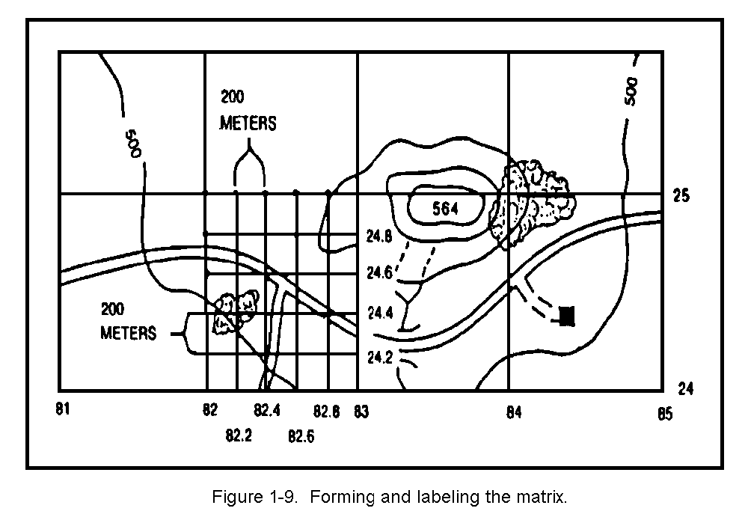
(d) Label the squares beginning at the lower left of the grid square. Number the lines to the right and up, as you would read a map.

(2) Construct the matrix. Divide the blank 1:25,000 map into 200 meter squares (Figure 1-10).
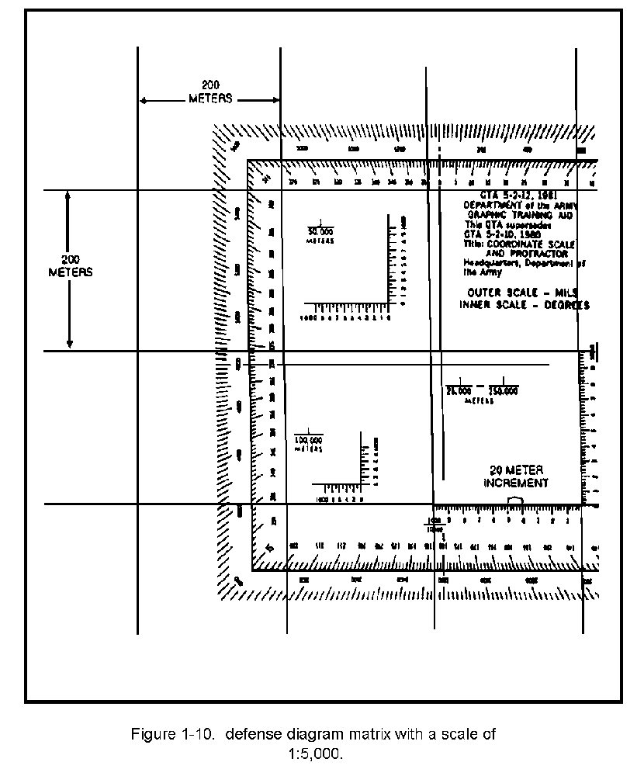
Expand the scale to 1:5,000 by using a blank 1:25,000 grid sheet. In expanding the scale to 1:5,000, each 200 by 200-meter block within the matrix correlates with a 1,000-meter grid square on the 1:25,000 grid sheet. Determine
which 200- by 200-meter block on the matrix contains the platoon center. In Figure 1-11, it is designated by 82.2--24.4. Next, select a square near the center of the blank grid sheet, and label this square the same. In our example this is 82.2--24.4. You have identified and labeled the 200- by 200-meter block where the platoon center is located. From this point, duplicate the labeling from the matrix on the grid sheet.

(3) Reproduce key terrain. Examine the 200- by 200-meter blocks on the 1:50,000 map that contain key terrain features that influence the defense. Sketch what you visualize in these blocks on the corresponding squares of the 1:5,000 scale grid sheet. The result is a map reproduction minus the contour lines and other data not pertinent to the defense of the platoon. However, contour lines representing hills or depressions may be included if they are deemed pertinent (Figure 1-11).
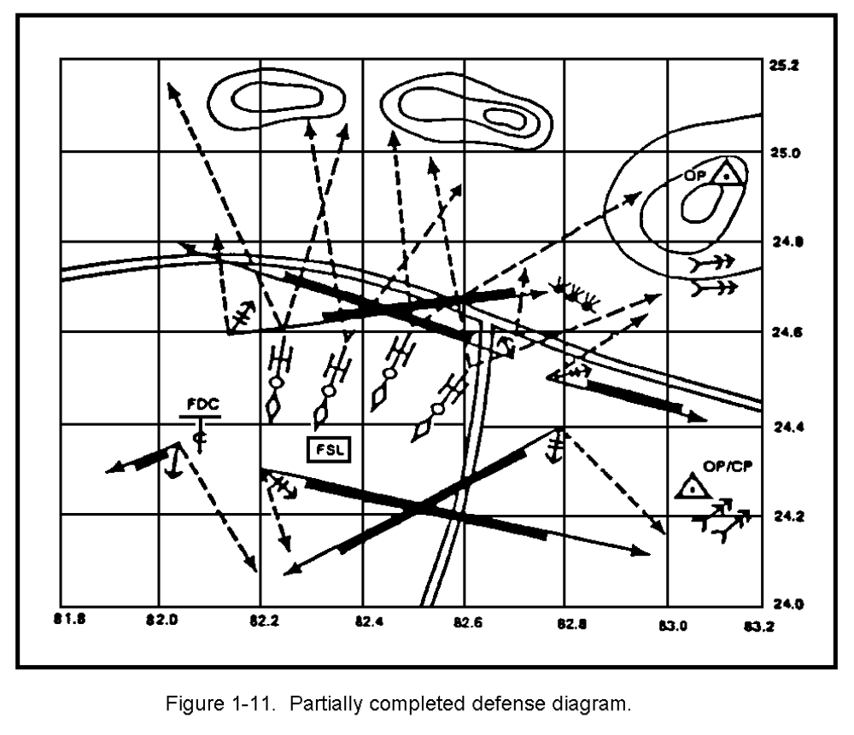
NOTE: The partially completed defense diagram for a firing platoon should look something like Figure 1-11. This example was drawn by an experienced draftsman. Your diagram need only be neat, concise, and accurate. Correct military symbols must be used. Refer to FM 21-30 for these.

(4) Draw the azimuth of fire. Use the coordinate scale to plot coordinates and to measure the distance on the 1:5,000 scale grid sheet. Using the coordinate scale, plot the platoon center on the 1:5,000-scale grid sheet. Construct a light line indicating the azimuth of fire. Next, draw a light line perpendicular to the azimuth of fire. Ensure that this line crosses the platoon center. These two lines are used for orientation in direction; that is, right, left, forward, and rear of the platoon center. (Once you have completed the diagram, you may erase these lines.)

(5) Plot Key Positions. Plot the required positions (such as howitzers, FDC or POC, LPs or OPs, crew-served weapons, tank killer team positions, and Killer Junior targets). Use howitzer grid coordinates obtained from the BUCS or map spot. In all cases, locations should be plotted within 10 meters and directions within 10 mils. On the diagram, the actual location of a weapon is indicated by the base of the stem of the weapon symbol. See FM 21-30 for symbols.

(6) Plot sectors of fire. The following sources are available to help in this task.

(a) Cannon range cards (DA Form 5699-R) indicate azimuths of the left and right limits. In addition, they should show key terrain features as well as predesignated targets with firing data. Cannon range card preparation is covered in depth later in this lesson.

(b) Machine gun range cards indicate the location (distance and direction from the platoon center or other known point) and the azimuths of the left and right limits and/or final protective line (FPL). The range card is prepared for all crew-served weapons. Details on preparation of this card is
given later in this lesson.

(7) Record the related information and grids on the back of the defense diagram (Figure 1-12).
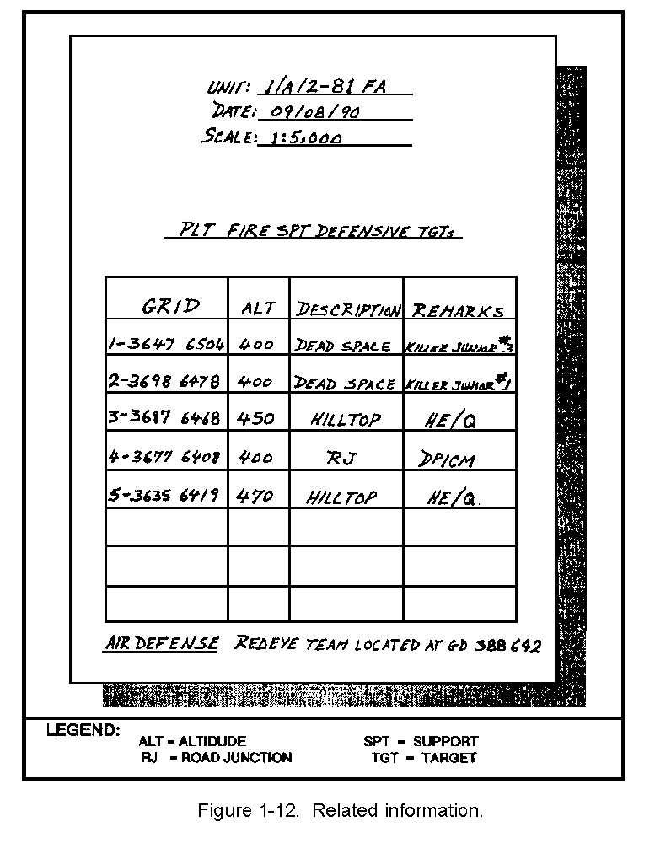
2. Disposition of the defense diagram.

The gunnery sergeant (GSG) begins to draw the defense diagram during the advance party operations. Once the main body completely occupies the new position, the GSG gives the platoon sergeant (platoon-based) or 1GS (battery-based) the diagram to be completed or to be checked and verified. If the battery is a platoon-based unit, the 1SG will collect both platoon diagrams and integrate them into the battery defense diagram. Then the battery diagram is sent to the battalion TOC for all units.

3. Preparing range cards.

a. Establishing sectors of fire. The platoon sergeant establishes the sectors of fire for the crew-served weapons. When these sectors have been determined and assigned, a range card will be constructed in duplicate for each primary position. A range card will be partially completed for each alternate and supplementary position. Range cards are continually updated and revised throughout the occupation of the position.

(1) Howitzer Range Card. The DA Form 5699-R (Howitzer Range Card) consists of two parts. A sketch of the sector of fire depicts targets and reference points. A data section lists data necessary to engage targets during periods of limited visibility. Procedures for completing DA Form 5699-R (Figure 1-13) follow:

(a) Begin a sketch of the assigned sector of fire. Depict left and right limits and potential targets and reference points in the SECTOR OF FIRE section. Identify the targets and reference points in your sketch by numbering them in order from the most probable to the least probable.

(b) While sighting along the bottom of the bore, direct the gunner to traverse and the assistant gunner to elevate or depress until the weapon is sighted on the left limit. Direct the gunner to turn the pantel, without moving the tube, onto the collimator (or primary aiming point) and to read the deflection (df) from the reset counter (or azimuth and azimuth micrometer scales). Record this deflection on the range card in the space marked LEFT DF. If the left limit is also a target, record the deflection in the DF column on the appropriate line for the target number. Direct the assistant gunner to measure the quadrant and record the quadrant. Complete the DESCRIPTION column by annotating a brief description of the target.
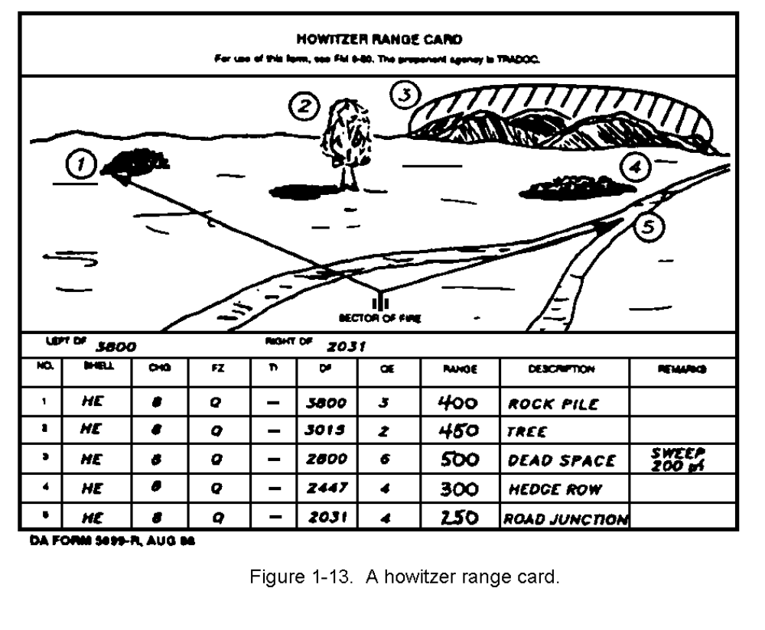
(c) Repeat these procedures for the right limit and for all target and reference points. Determine the shell, charge, and fuze to be fired for each target; and record that information in the appropriate columns. Use the REMARKS column to indicate additional information needed to engage the target; for example, Sweep 200 meters (m).

(d) The measured quadrant and range should be given to the FDC to be converted into a true quadrant. Then record the true quadrant on the range card in the QE column.

(e) When the range card is completed (example Figure 113), make a duplicate card for the platoon sergeant. Continue to update and review the range card throughout occupation of the position.
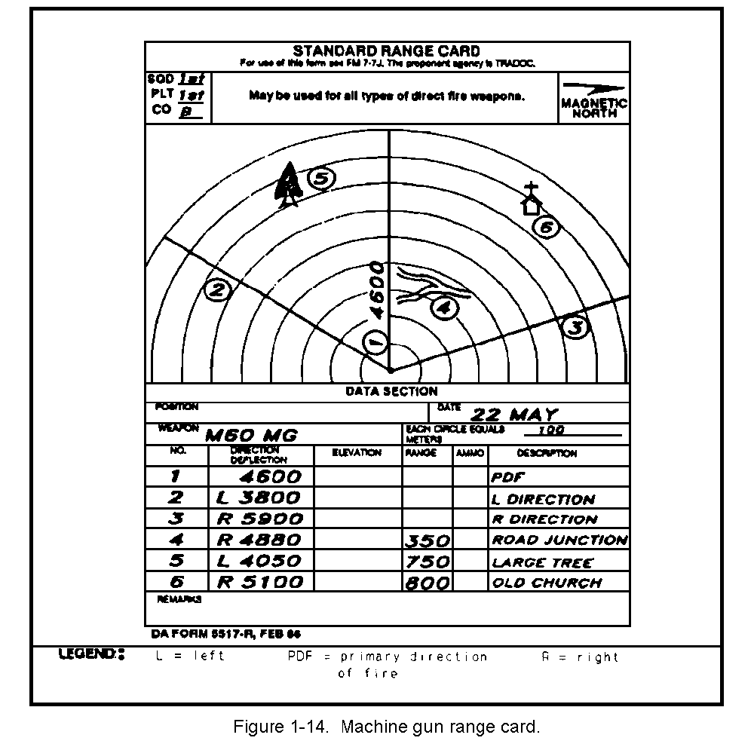
(2) Machine Gun Range Card. The machine gun range card DA Form 5517-R (Figure 1-14) consists of two parts--a sketch of the sectors of fire and a data section that lists data necessary to engage targets during periods of limited visibility. The sketch depicts the primary and secondary sectors of fire, the location of the weapon, the azimuths of the left and right limits and the final protective line, and any dead space.
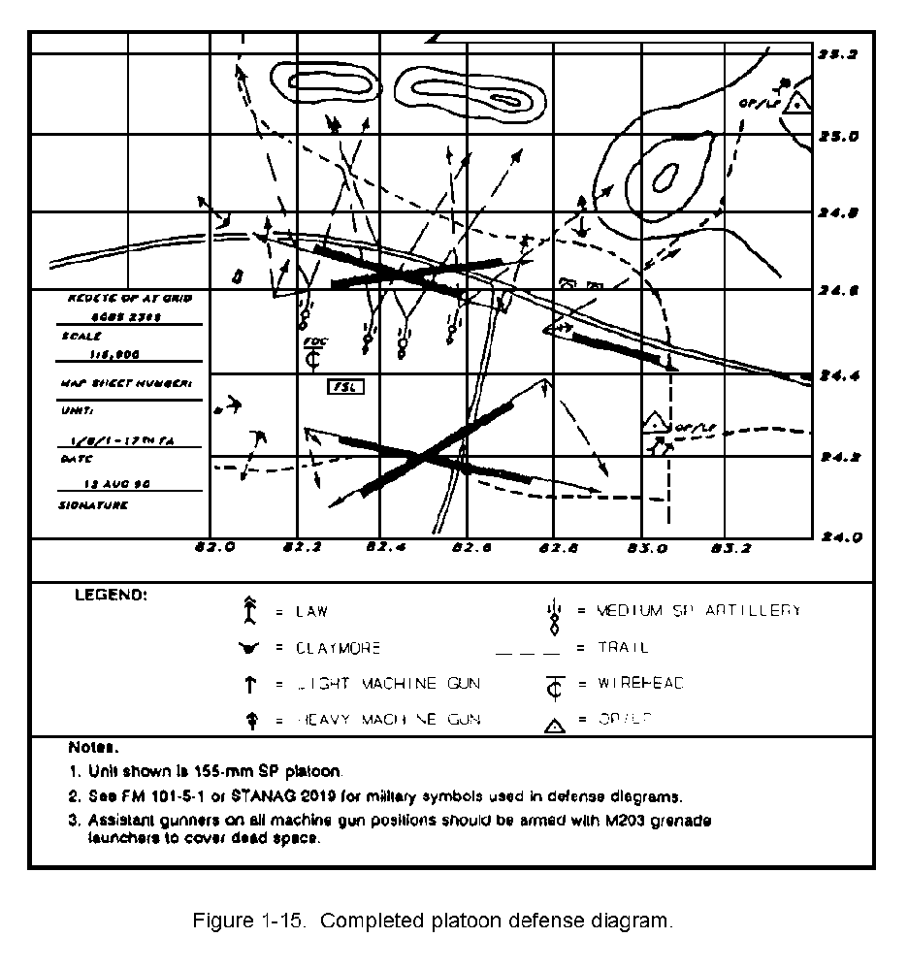
b. Once the range cards are collected by the platoon sergeant, they are used in constructing the sectors of fire on the defense diagram. The result is a completed defense diagram with all pertinent data for the platoon defense (Figure 1-15).

4. Highlights of the defense plan.

Note that this defense diagram (Figure 1-15) considers some basic principles of defense. These principles are discussed below.

a. Machine guns. Machine guns (M60) are used both on the outposts and on the perimeter. Machine guns on the perimeter must be sited to provide covering fire for the outposts. The sectors of fire from these positions overlap to provide a continuous belt of flanking-grazing fire around the position. Several positions may be selected for each machine gun--outpost position for normal daylight use, positions on the perimeter for use at night, and positions for use after the withdrawal of outposts.

b. Antitank weapons. The AT weapons available to FA units are the LAW and the Dragon AT rocket launcher. These weapons may be used effectively beyond and within the defense perimeter and as armament for the security force. Positions should not be located more than 200 meters beyond the perimeter. Antitank weapons should be placed between the OPs and the battery position and along routes the antitank teams use to attack at close range with surprise flanking fires.

c. Air defense weapons. Ring-mounted machine guns (.50 caliber) that are organic to the unit, reinforced with small arms fire, provide defense against air attacks. Positions that provide cover from the primary low-altitude flight avenues of approach into the platoon area should be chosen.

d. OPs and LPs. OPs and LPs must be positioned far enough from the platoon to provide early warning and time to react to a particular threat. As a general rule of thumb, OPs should be positioned to allow at least a 2,500- to 3,000-meter advance warning of an impending armor or mechanized attack. The distance depends on visibility, the closing speed of the enemy, and the extent to which the terrain masks the positions from direct fire weapons. Observation posts are positioned to cover all avenues of approach. Several may be required to provide full coverage. Listening posts augment OPs when visibility is reduced and fill gaps when OPs are withdrawn at night. The LPs and OPs should be withdrawn when engagement is imminent. Each OP and LP should be manned by at least two men, and each location should have a primary and an alternate means of communication. Anti-intrusion devices (Appendix B) can supplement OPs and LPs, and they can range from rocks in tin cans to trip flares, to sophisticated electronic devices.

e. Obstacles. Obstacles are used to delay, stop, divert, or canalize an attack force. Time and material available dictate the degree of construction of man-made obstacles. Tactical obstacles are natural terrain features, soil conditions, or man-made obstructions that deny the enemy entry into an area, delay his advance, confine his approach to a definite route, or force him to deploy his troops prematurely. To be most effective, obstacles should be covered by fire. Constructing obstacles for close-in defense is the responsibility of the unit occupying the area. Obstacles are classified as natural or artificial.

(1) Natural obstacles include steep banks, streams, canyons, swamps, and heavy woods. Man-made obstacles, such as buildings or walls, which were not originally erected, to serve as obstacles are also classified as natural obstacles. Existing natural obstacles may be strengthened by using artificial obstacles. Natural obstacles in the area are considered in selecting artillery positions. For example, an unfordable stream or deep ravine adjacent to the position would provide antitank protection for that particular side.

(2) Artificial obstacles are passive defensive measures constructed and positioned by a unit for its own defense. These obstacles include barbed wire entanglements, minefields, roadblocks, and antitank ditches. Engineer troops furnish technical advice on the construction of obstacles. However, their actual construction is the responsibility of the unit. Artificial obstacles are located close enough to the platoon to permit day and night surveillance. These obstacles should be far enough away from the platoon to prevent damage from hand grenades thrown from beyond the obstacle.

(3) In the artillery, the construction of artificial obstacles is restricted because of labor and material requirements. Therefore, the defense must exploit the natural obstacles in the area. The use of barbed wire and minefields to close gaps between natural obstacles provides the most practical means for the artillery to construct a zone of obstacles. Ingenuity is required in constructing and using obstacles, since each separate position presents a different problem. Both natural and artificial obstacles must be covered by observation and fire to be effective.

PART D - COMMUNICATIONS IN THE DEFENSE

The cannon battery or platoon uses both radio and wire equipment. Either system will become primary or secondary, depending on the tactical situation and the availability of equipment. There are advantages and disadvantages associated with each. For example, radio permits mobility and speed but is susceptible to enemy electronic warfare (EW). Wire lines are more immune to enemy EW, but they inhibit rapid movement and speedy installation. Therefore, it is best to consider battery or platoon communications as a system that makes the best use of the radio and wire resources that are available at any given time. Platoon leaders must strive to have redundant systems. That is, if radio is the primary communication means, back it up with wire; or, if wire is the primary communications means, back it up with radio. Ideally, it would be best to rely on radio during displacements and the initial site occupations. Then, if time permits, install and operate on wire lines. If radios are unavailable, or unusable, a wire system is necessary.
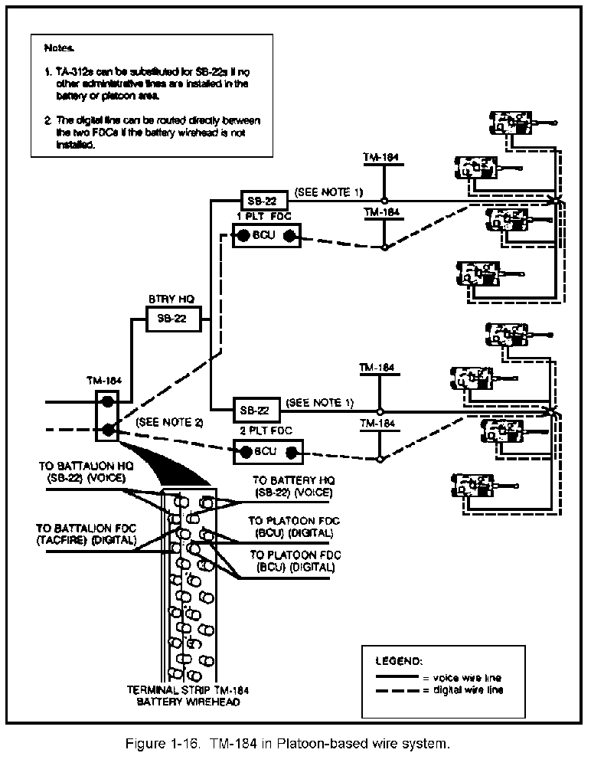
Chapter 9, 6-50 contains diagrams and system configurations that show practical and realistic ways of establishing battery communications systems by TOE. The rest of this PART will discuss basic doctrinal concepts of battery and platoon communications in the defense.

a. Presently, the FA battery or platoon relies on wire to meet its internal communications needs. Three DR-8s are issued to each howitzer section so the battery can have separate voice, digital and advance party capabilities.

b. There are changes to the wire terminals used in the battery wire system. The SB-16 is no longer recommended for digital communications. Terminal strip TM-184 (Figure 1-16) provides a cleaner, more reliable digital signal. The TM-184 (NSN 594000-238-8493) is a Class IX item and can be procured through the unit supply system. Four TM-184s are required to install the battery or platoon wire system. One serves as the voice wire head, one as the digital wire head, and one for an advance party capability. The fourth connects battalion wire lines. Two additional TM184s are required for the second platoon in a platoon-based battery.

SUMMARY

An FA unit must be prepared to resist attacks against the position area and to engage in close combat with the enemy when necessary to accomplish the mission.

Careful planning for a flexible, all-around, in-depth defense starts with the selection of a defensible position area. The position selected for a defense must be such that the enemy can be engaged at maximum range and brought under an increasingly heavy volume of fire as he approaches the position area. Sectors of fire are assigned to each firing section to provide the unit with all-around, interlocking direct fire.

Machine guns are positioned to provide all-around coverage of the perimeter and should be mutually supporting. Antitank weapons are used along likely avenues of approach with a series of preselected supplementary positions. Air defense, the ring mounted .50 caliber machine guns, covers likely air avenues of approach into the position area. Observation and listening posts provide early warning of enemy activity, and the reaction force reinforces any part of the perimeter that may have been penetrated.

Standing operating procedures must prescribe routine procedures in sufficient detail to ensure adequate and correct immediate action against any potentiality. SOPs must be rehearsed frequently to be effective. The platoon establishes a warning system and provides for mutual warning between supported, adjacent, and higher echelons. The system consists of OPs, LPs, patrols, ground sensors, and visual and audio alarm devices. Mutually supporting artillery fires are habitually planned between firing units. Light and noise discipline is constantly practiced and enforced.

The defense diagram is a sketch drawn to scale (1:5,000) of the platoon defensive resources as they are employed. By considering the nine fundamental considerations of defense, coupled with common sense, the defense diagram is a valuable tool to the commander. Remember, the preparation and analysis of the platoon defense diagram are ongoing processes. To facilitate the defense of the platoon, the diagram must be constantly reviewed and updated as defensive resources are shifted.

LESSON 1

PRACTICE EXERCISE

The following items will test your grasp of the material covered in this lesson. There is only one correct answer for each item. When you complete the exercise, check your answer with the answer key that follows. If you answer any item incorrectly, study again that part of the lesson which contains the portion involved.

1. The reference for defense of the FA battery is:

A. FM 6-40
B. FM 6-20
C. FM 6-50
D. FM 6-20-30

2. Detection of FA units by the threat is done through the study of doctrine and processing of:

A. MTI radar reports.
B. Remote sensing activity.
C. Satellite imagery.
D. SIGINT, IMINT, HUMINT.

3. The enemy can get a fix on friendly transmissions through triangulation and begins his targeting sequence ___________________ after communications begin.

A. 15 seconds
B. 25 seconds
C. 35 seconds
D. 45 seconds

4. Friendly tactical FM radios operating on low power can be picked up by enemy RDF units at distances over ________________ kilometers.

A. 10
B. 20
C. 30
D. 40

5. Radars can detect firing weapons to an accuracy of ____________ to ____________ meters.

A. 25:50
B. 50;75
C. 75;150
D. 150;300

6. RDF accounts for 10 percent of enemy detections of friendly artillery sound and flash provides about ________ percent of enemy target acquisition.

A. 90
B. 80
C. 70
D. 60

7. The threat can suppress or destroy a battery by the use of:

A. Counterfire, air attack, ground forces, and radio electronic combat.
B. Counterfire, air attack, ground forces, and moving target imagery.
C. Counterfire, air attack, ground forces, and imagery intelligence.
D. Counterfire, air attack, ground forces, and signals intelligence.

8. Enemy counterfire attacks comprise up to 600 rounds fired into a _____________ by ________________ meter area.

A. 200;100
B. 400;200
C. 200;200
D. 200;400

9. REC combines direction finding, intensive jamming, deception and _____________

A. imitation.
B. triangulation.
C. counterfire radars.
D. destructive fires.

10. Future enemy phased array radars will have a TLE of:

A. 75 to 100 meters.
B. 100 meters.
C. 75 meters.
D. 50 meters.

11. Currently CB radars have a range of _______________ kilometers.

A. 20
B. 30
C. 40
D. 50

12. SMALL FRED MTI radars have a range of _____________ KM and a TLE of under _________ meters.

A. 10;50
B. 20;50
C. 20;75
D. 10;75

13. The ___________________ integrates the platoon defense plans into an overall battery defense plan.

A. battery commander (BC)
B. XO
C. first sergeant
D. platoon sergeant

14. Responsibility for general planning, coordination and execution of the platoon defense is the responsibility of the

A. BC
B. first sergeant
C. platoon leader
D. platoon sergeant

15. The person responsible for ensuring that howitzer and crew served range cards are prepared is the:

A. first sergeant.
B. platoon sergeant.
C. section chief.
D. gunnery sergeant.

16. The person who ensures that individual and crew-served fighting positions are properly prepared is:

A. first sergeant.
B. platoon sergeant.
C. section chief.
D. gunnery sergeant.

17. "Use of terrain" is important in defense planning. What are the two general considerations involved in using terrain?

A. camouflage and fortification
B. site selection and spoil
C. natural camouflage and position improvement
D. movement and use of color

18. Four of the six factors of recognition are:

A. Position, color, shape, and light.
B. Position, shape, shadow, and texture.
C. Position, texture, movement, and smoothness.
D. Position, shape, texture, and darkness.

19. How is movement a recognition factor?

A. It reveals the identity of an object.
B. It reveals not only the identity of objects, but also the activity taking place.
C. It reveals the existence of an activity.
D. It is useful only to human observers who can see movement of units occurring.

20. Artificial camouflage that can reduce the chance of recognition are:

A. shadows and LWSS.
B. the LWSS and buildings.
C. the NATO three-color pattern on equipment and buildings.
D. The NATO three-color pattern on equipment and the LWSS.

21. A way to avoid showing movement in the battery area is:

A. for ground guides to direct traffic throughout the occupation of the position.
B. to create trails to confuse enemy observers.
C. to allow the first sergeant to enforce his track plan.
D. for the BC to enforce his track plan.

22. The concept of occupying positions that have natural advantages for defense, such as interior tree lines and ravines is called:

A. defensible terrain.
B. key terrain.
C. position improvement.
D. observation and fields of fire.

23. Hardening battery positions and digging in whenever possible are examples of:

A. defensible terrain.
B. position improvement.
C. use of obstacles.
D. spoil.

24. To complete the job of camouflaging, spoil must be:

A. removed from the battery position.
B. used to construct obstacles.
C. buried. FM 5-103 lists methods for this type of disposal.
D. camouflaged.

25. Considerations in determining the location of observation posts (OPs) or listening posts (LPs) include:

A. Avenues of approach and key terrain.
B. Observation and fields of fire.
C. cover and concealment.
D. All of the above.

26. After occupying a position, the first order of business is to:

A. Harden positions.
B. Establish communications to higher headquarters.
C. Establish security.
D. Establish platoon communications.

27. Part of the reaction force consists of:

A. One man per howitzer section.
B. A designated howitzer section to maintain unity of command.
C. The communications section after commo is established.
D. A platoon leader as OIC.

28. As a minimum a platoon should disperse:

A. over a 100 by 200 Meter area.
B. over a 200 by 400 meter area.
C. so that the howitzers are no more than 50 meters apart.
D. so that the FDC is not less than 200 meters from either flank howitzer.

29. Which of the following is a true statement about setting priorities?

A. The two most common situations are; "continue mission in position", and "displace on receiving fire".
B. Once the defensive mission is known, the platoon leader can use on of the priority lists in this subcourse.
C. Hardening positions is always the first priority.
D. Camouflage is always the first priority.

30. The defense diagram is a key visual aid to insure:

A. All defensive fires available are placed to the battery or platoon fronts.
B. That battery personnel emplace howitzers in designated areas.
C. That there is a plan which provides 6,400-mil coverage for the battery.
D. That the FDC is sited correctly.

31. Who prepares the defensive diagram?

A. GSG then platoon sergeant (battery-based)
B. Platoon sergeant then first sergeant (battery-based)
C. Platoon sergeant then platoon leader (platoon-based)
D. GSG then first sergeant (battery-based)

Problems 32, 35, and 34 form a practical exercise that requires you to prepare a defense diagram for a firing platoon and analyze the defense diagram to determine the effectiveness of existing defenses. Tear out the following items from the back of this booklet.

- Blank grid sheet.
- Map sheet. (Appendix A)
- Coordinate scale. (Appendix A)
- Protractor. (Appendix A)
- Data sheet. (Appendix A)

32. SITUATION: Battery A, 1st Bn (155-mm SP), 40th FA, has just occupied a firing position as indicated on the data sheet. The platoon sergeant has compiled notes on the various defensive positions from the platoon leader's report (piece distribution), from howitzer range cards, from machine gun (MG) range cards, and from actually checking the defensive resources as they are used. You are PSG of the 1st Platoon, Battery A.

PROBLEM: Using the 1:50,000 map, a 1:25,000 grid sheet, and plotting equipment, enlarge the scale of the map to 1:5,000. Next, locate and plot the platoon center. (Use the information in the data sheet provided in the appendix.) Finally, annotate the appropriate marginal information.

33. SITUATION CONTINUED: As platoon sergeant, you have completed the defense diagram as prescribed above. The location and fields of fire for the weapons are now available to you. See data sheet.)

PROBLEM: Plot the weapon locations and assigned sectors of fire on the defense diagram. Analyze the diagram to determine if your defense resources have been effectively used. Light machine guns should not be assigned a primary sector of fire in excess of 875 mils. If necessary, secondary sector of fire may be assigned. The length of the sector should be extended to 600 meters, which correlates with the weapon grazing-fire capability. If the weapon has been assigned a final protective line (Not all of the machine guns are assigned an FPL), this will be indicated by a dark shaded line to portray that area along the fixed line of fire in which the cone of the trajectory does not rise above 1 meter. Areas in which 1 meter is exceeded are not shaded and reflect dead space. All dead space should be covered by mutually supporting weapons.

34. SITUATION CONTINUED: The preparation of a platoon defense diagram is an ongoing process. As you continue to analyze the employment of defensive resources on the ground and improve your position area, the platoon defense diagram is updated. You have completed the defense diagram. The locations of the OP and the FDC are now available to you (see data sheet).

PROBLEM: Plot the locations of the OP and the FDC on the defense diagram. Analyze the diagram to determine if these installations are tactically sound locations.

PRACTICE EXERCISE

ANSWER KEY AND FEEDBACK

Item Correct Answer and Feedback

1. C. FM 6-50

This lesson is based on FM 6-50, The Field Artillery
Cannon Battery. (References).

2. D. SIGINT, IMINT, HUMINT.

The enemy will try to detect FA elements through the study of our doctrine and the collection of signals intelligence (SIGINT), imagery intelligence (IMINT), and human intelligence (HUMINT). [para 1(1)].

3. B. 25 seconds

Using signal intercept and radio direction finding (RDF) equipment, the enemy collects various frequency modulated (FM) and amplitude modulated (AM) radio transmissions. Through triangulation, the enemy fixes the signal. About 25 seconds after communications begin, the enemy can begin his targeting sequence. [para 1a(1)].

4. A. 10

Tactical FM radios operating on low power can be picked up by enemy RDF units at distances in excess of 10 kilometers. High-power signals can be detected at distances up to 40 kilometers. [para 1a(1)].

5. C. 75;150

Other targeting means are radars, sound, and visual target detection teams. Radars can detect firing weapons to a 75-150 meter accuracy, but they depend on survey and the weapon trajectory. Higher trajectories produce more accurate results. [para 1a(2)].

6. C. 70

RDF accounts for 10 percent of enemy detection of friendly artillery; sound and flash provide about 70 percent; while radar and visual assets provide the remaining 20 percent. [para 1a(2)(a)].

7. A. Counterfire, air attack, ground forces and radio electronic combat.

Threat forces can suppress or destroy a battery by the following techniques: Counterfire, Air attack, Ground forces, and Radio electronic combat (REC). (para 2).

8. A. 200;100

- Counterfire. Enemy attacks with upward of 600 rounds fired into a 200 X 100-meter (m) area. (para 2).

9. D. destructive fires.

- Radio electronic combat (REC). REC combines SIGINT, direction finding, intensive jamming, deception, and destructive fires to attack enemy organizations and systems. (para 2)

10. D. 50 meters.

Counterbattery (CB) radars currently have a range of 20 km with nominal target location error (TLE) of 75-100 meters. Fifty meter TLE is expected with phased array radars. (para 3a).

11. A. 20

See the answer to question 10, above. (para 3b).

12. B. 20;50

Currently, SMALL FRED (MTI) radars have a range of 20 km and TLE of under 50 meters. (para 3b).

13. C. first sergeant

The first sergeant integrates the platoon defense plans into an overall battery defense plan. (para 4b).

14. C. platoon leader

The BC or platoon leader is responsible for general planning, coordination, and execution of the defense of his battery or platoon and for establishing defensive priorities. (para 4a).

15. C. section chief

The section chief ensures that the howitzer range card and crew-served weapons range cards are prepared. (para 4d).

16. C. section chief

The section chief ensures that individual and crew-served fighting positions are properly prepared and have adequate overhead cover. (para 4d).

17. A. camouflage and fortification

Two major considerations in planning to use terrain are camouflage and fortifications. The terrain that you are given to defend will determine the time and energy needed to construct an adequate defense. (para 1).

18. B. Position, shape, shadow, and texture.

Soldiers must understand the six factors of recognition: position, color, shape, shadow, texture, and movement in order to survive on the battlefield. (para 1a).

19. C. It reveals the existence of an activity.

Movement does not actually reveal the identity of an object but it does reveal the existence of an activity. When all other factors of recognition have been completely eliminated, a position can still be revealed to observers if movement is not controlled. (para 1a).

20. D. The NATO three-color pattern on equipment and the LWSS

Two artificial camouflage measures that can reduce the chance of recognition are pattern painting of equipment with the NATO three-color patterns and proper use of the lightweight screening system (LWSS). (para 1a).

21. D. for the BC to enforce his track plan.

As explained above, the most common signs of military activities in an otherwise well camouflaged area are tracks, spoil (dirt residue from digging fighting positions), debris, and movement. The BC must enforce his track plan. Existing roads and trails must be used. (para 1a).

22. A. defensible terrain.

Construction of fortifications is the second use of terrain that must be considered by leaders. Use defensible terrain. That is, occupy positions that have natural advantages for defense, such as interior tree lines and ravines. (para 2a).

23. B. position improvement.

Position improvement. Harden battery positions and dig in whenever possible. FM 5-103 shows good examples of hardened positions. (para 2b).

24. D. camouflaged.

Spoil is the residue left over from digging in equipment and individual fighting positions. This includes dirt thrown out of these positions. To complete the job of camouflaging a position, spoil must also be camouflaged. (para 2e).

25. D. All of the above.

When determining the location of the OPs and/or the LPs, consider observation and fields of fire, cover and concealment, key terrain, avenues of approach, and METT-T. (para 1).

26. C. Establish security.

The cannon battery or platoon is highly vulnerable to attack as it occupies or displaces from a position. The first order of business is establishing security. (para 4a).

27. A. One man per howitzer section.

A suggested composition of the reaction force includes a reaction force NCOIC (platoon sergeant), one man per howitzer section, and one man each from the FDC or POC, communication section and maintenance section. (para 4b).

28. B. over a 200 by 400 meter area.

Dispersion minimizes the effects of an air attack or a counterfire attack. When using this technique, units should disperse, as a minimum, over a 200- by 400-meter area with howitzers no closer than 100 meters. The FDC should be positioned about 100 meters from either flank howitzer. Figure 1-7 shows a platoon position with elements dispersed. (para 5).

29. A. The two most common situations are; "continue mission in position", and "displace on receiving fire".

Priorities for the defense are highly dependent on many variables of situation, mission, and scheme of maneuver. However, the two most common situations are "continue mission in position", and "displace on receiving fire". (para 6).

30. C. That there is a plan which provides 6,400-mil coverage for the battery.

The defense diagram is a key visual aid to insure there is a defense plan which provides 6,400-mil coverage for the battery. Also, this diagram is sent to battalion and is used to develop a battalion defensive fire support plan. (Part C).

31. D. GSG then first sergeant (battery-based)

The gunnery sergeant (GSG) begins to draw the defense diagram during the advance party operations. Once the main body completely occupies the new position, the GSG gives the platoon sergeant (platoon-based) or 1GS (battery-based) the diagram to be completed or to be checked and verified. (para 2).

32. The first step in enlarging the scale of the map is to locate the platoon center on the 1:50,000 map and identify the surrounding squares that influence the defense of the platoon. Once you have determined the entire area that affects the defense of the platoon, place tack marks at 200-meter intervals along the sides of the 1,000-meter grid square(s). By drawing lines, connect the tick marks to form a matrix on your map. Each matrix superimposed on a 1,000-meter grid of the 1:50,000 map is now viewed as containing twenty-five 200- by 200-meter squares. In expanding the scale to 1:5,000, each of these 200-meter blocks within the matrix correlates with each 1,000-meter grid square on a 1:25,000 grid sheet. Upon completing the matrix, number each line in the matrix beginning at the lower left of the grid square. Number the lines to the right and up, as you read a map, and reflect the 200-meter interval; that is, grid square 50 39--lower left to right 50.0, 50.2 to 50.4, 50.6, 50.8,
51.0; from lower left and up 39.0, 39.2, 39.4, 39.6, 39.8, and 40.0.

The second step is to enlarge the 1:50,000 scale to a 1:5,000 scale by modifying a 1:25,000-scale grid sheet. Each 1,000-meter grid square on the 25,000 grid sheet represents a 200-meter block as formed by the matrix constructed on the 1:50,000 map. By being aware of the location of platoon center, you can determine the grid square(s) to be expanded. Select a 1,000-meter grid square near the center of the 1:25,000 grid sheet by using the same matrix-numbering procedure as above. Label the 1:25,000 grid sheet. This results in a new scale of 1:5,000.

NOTE: The coordinate scale 1:50,000 may be used effectively to plot coordinates and to measure distances on the developed 1:5,000 scale by dividing the indicated graduations by 10; that is, the 1,000-meter graduation is read as 100 meters, the 100-meter graduation is read as 10 meters, and the 50-meter graduation is read as 5 meters. A simple technique of converting the 1:50,000 scale to the 1:5,000 scale is to mentally drop the last 0 of the 1:50,000 designated graduations. The use of the protractor in measuring azimuth (az) or direction will not change.

The third step is to plot platoon center on the 1:50,000 scale using the coordinate scale (drop the last 0). Construct a light line (indicates the azimuth of fire [AOF]), ensuring that the line crosses platoon center. These two lines are used for orientation in direction; that is, to indicate right or left, forward or rear of platoon center. Upon completion of the platoon defense diagram, these lines may be erased. At this point, after critical examination of the terrain, draw in only those features that affect the defense of the platoon. Ordinary contour lines and unnecessary terrain features only add confusion to the defense diagram and should not be included. The marginal information includes (as a minimum) your unit identification, scale, reference map sheet, date, and your signature. See Figure 1 for one solution to exercise 32 and what your defense diagram should look like at this point.
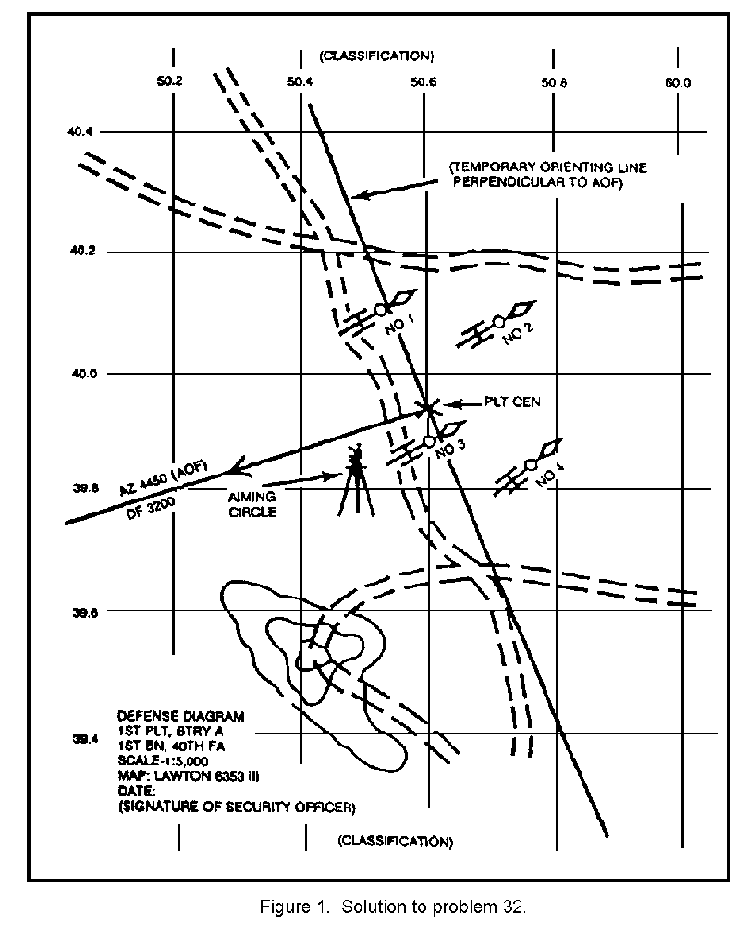
33. The weapons locations and the sectors of fire are plotted as accurately as possible. In all cases, the locations must be within 10 meters and the directions within 10 mils. The actual location of the weapon symbol. In addition, all measurements in direction for sectors of fire are made from the base of the stem of the weapon symbol. Figure 2, answer to exercise 33, portrays the data you should have plotted on the defense diagram up to this point.

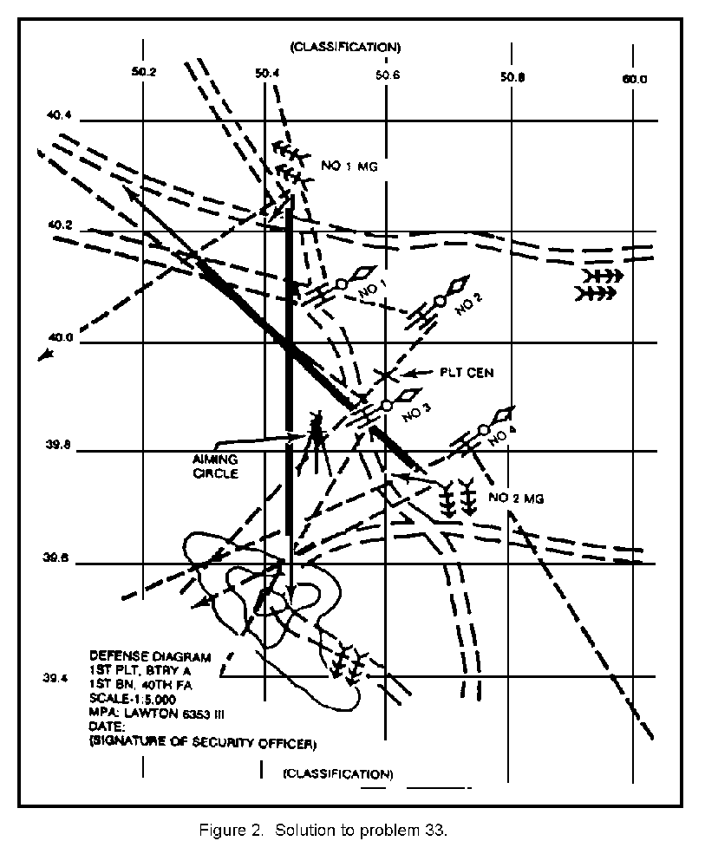
34. An analysis of the terrain around the position must include the identification of key terrain (terrain that would provide a marked advantage to either force), and a decision must be made to control this key terrain either by physical occupation or by planned fires. Because of the limited number of personnel assigned by tables of organization and equipment (TOE), the control of many of these areas is accomplished by planned fires. At the same time, there may be some areas that dictate physical occupation. In the presented situation, only one of the areas must be occupied to be controlled effectively. The rest of the critical terrain would be controlled by use of planned fires. On a dynamic battlefield, our unit will be subjected to extensive, if not massive, counterbattery fire. Realizing this, and at the same time knowing that the enemy's greatest probable error is in range, we want to place the FDC behind the gun line and off to one of the flanks of the platoon. However, the FDC should not be placed so far out that it becomes isolated from the platoon or is, in effect, positioned outside the platoon perimeter. Figure 3 (answer to exercise 34) shows the completed defense diagram and portrays the information that should appear on the defense diagram you have completed in this requirement.

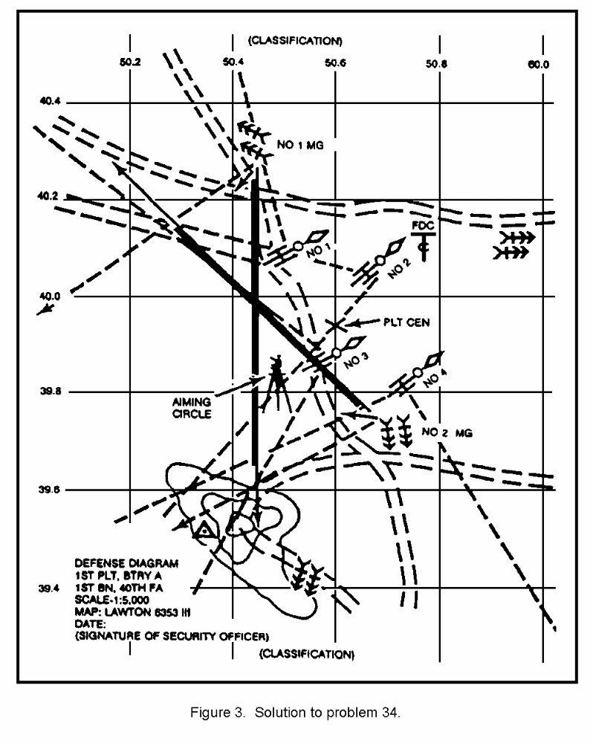

LESSON 2

CONDUCT OF THE DEFENSE

Critical Task: 01-2660.01-0052
061-266-4016

OVERVIEW

LESSON DESCRIPTION

In this lesson you will learn techniques that will allow you to prepare a platoon or battery to defend against a variety of ground and air threats as well as against the NBC threat. You will also be able to identify techniques for evaluating the defensive plan on the ground.

TERMINAL LEARNING OBJECTIVE

ACTION: Select the appropriate defensive course of action based upon the tactical scenario.

CONDITION: Given the material contained in this lesson.

STANDARD: Correctly answer all questions in the practice exercise at the end of this lesson

References: This lesson is based on FM 6-50, The Field Artillery Cannon Battery, and other materials approved for US Army Field Artillery School instruction. However, development and progress render the text continually subject to change. Therefore, base your examination answers on material presented in this text rather than on individual or unit experience.

INTRODUCTION

Recent world and national events could lead to wrong conclusions about the need to rehearse for a variety of defensive scenarios. The dissolution of the Warsaw Pact and the crumbling of the Soviet Union may lead to the conclusion that war against a threat with military strength equal to the U.S. is now remote. Victories in operations Just Cause (Panama) and Desert Storm (Iraq) may also lead to wrong assumptions about future wars. In both instances, the potential for enemy offensive operations was curtailed by a combination of surprise in the air/ground maneuver or by overwhelming air superiority which rendered the offensive threat ineffective. However, the important thing to remember is that the potential for enemy offensive operations was there and will continue to be present in all future battles. It is also important to remember that the high technology that made our victories possible is possessed by other nations who are willing to put it up for sale on the world's arms market. It is, therefore, important for BCs and platoon leaders to be ready for any form of enemy attack.

PART A - RESPONDING TO ENEMY ATTACK

1. Defense against an armored or mechanized force.

a. Enemy ground actions. If an enemy armored or mechanized force detects the battery or its platoons, the enemy can be expected to take the following actions:

(1) Tanks will try to overrun the firing battery positions.

(2) Assault vehicles will fire antitank guided missiles, 73-mm guns, and machine guns from standoff positions.

(3) These actions will be followed by mounted or dismounted attacks through the battery area.

b. Friendly response to attack. The preferred defense against an armored or mechanized ground attack is for the battery or platoon to avoid direct engagement and move to alternate positions in order to continue the fire support mission. When engagement is unavoidable, some combat proved rules for fighting mechanized forces are:

(1) Separate the infantry from the tanks. This can be accomplished by the use of mines, APERS rounds or Killer Junior.

(2) Slow down the tanks. Use smoke mixed with HE to obscure the enemy's vision and keep tanks buttoned up.

(3) Canalize tanks into predetermined kill zones by using obstacles and fire support means.

2. Defense against an air attack.

a. The primary way for an FA battery to survive when the enemy has air parity or superiority is to be so well concealed that the enemy cannot acquire the battery. If the battery is detected and attacked, the key to survival is dispersion and engaging attacking aircraft with a large volume of fire.
Immediate actions against air attack are as follows:

(1) The warning signal for an imminent air attack is given.

NOTE: The BC must insure that emergency alarms of hazard or attack are provided in the unit SOPs. The applicable details to be included in the SOPs have been extracted from STANAG 2047 and are found in Chapter 3, FM 6-50.

(2) Every soldier takes cover and prepares to return fire.

- All weapons in the battery are used to return fire. Accuracy is
not as important as mass (Figure 2-1).

- A lead equal to two football fields should be used for fast
Moving aircraft. A lead equal to one-half a football field is used for slow-moving aircraft (helicopters).

- Ring-mounted machine guns (.50 caliber) are the only organic air
Defense weapons in the battery. Primary or supplementary positions selected by the battery should be occupied by the vehicles Figure 2-1. Mass battery fires with ring-mounted weapons Field Artillery Ammunition Support Vehicles [FAASV] and M548 cargo carriers) to return fire.

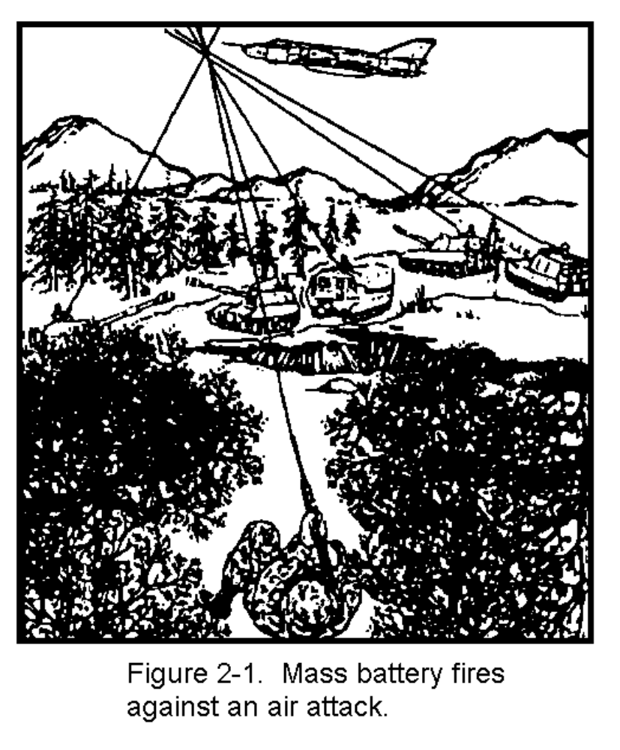
(6) Stinger and/or Redeye teams from division or corps air defense battalions engage enemy aircraft. If available, these teams should be positioned to cover primary low-flight avenues of approach into the battery area. Their sector of fire must include the airspace over the battery.

- Defense for convoys. Defense of convoys against air attack is as follows:

(1) Move the battery at night, on concealed routes, or during periods of reduced visibility.

(2) Consider infiltration (i.e., moving small groups of personnel and equipment) if there is a significant air threat.

(3) Post air guards for each vehicle, and assign sectors of responsibility that permit massing small-arms fires.

(4) Immediate action against air attack is to disperse vehicles. Everyone must return fire.

3. Defense against dismounted attack.

a. Enemy dismounted attack techniques. Dismounted enemy elements will attack by use of the following:

- Ambushes.

- Guerrilla-type attacks (normally not exceeding platoon size and often conducted at night or in adverse weather).

- A diversionary attack and then a main attack.

- Dismounted infantry.

b. Friendly actions against dismounted attack. A properly equipped 10-man enemy combat patrol can effectively neutralize a cannon battery that is lax in its defense planning or execution. To keep this from happening, the battery must do the following:

- Fight the enemy outside the position.

- Ensure fighting positions provide interlocking sectors of fire around the position.

- Use an overwatch technique--one element covers the movement of another if defense personnel must withdraw to alternate positions.

- Chase the enemy with artillery fires when he is beaten back. Do not dispatch forces to chase him

- Use mines, barbed wire, and other obstacles.

c. Additional friendly courses of action. An additional defense against a ground attack (mounted or dismounted) is for the battery or platoon to displace to an alternate position.

4. Defense in a Low Intensity Conflict (LIC) environment.

Any number of possible contingency missions may involve the battery in a LIC environment. This is particularly true of artillery units that support light forces. The specifics of battery defense in LIC depend largely on the situation. Also, they are largely determined by the equipment and offensive capability of the enemy force. In most situations involving LIC, the Threat consists of paramilitary or guerrilla forces with minimum heavy weapon, armor, or air support. The primary ground threat to the battery is dismounted attack by light infantry or infiltration by sappers or saboteurs. In this situation, the best defensive solution is consolidation of the battery elements into a strong defensive perimeter, often called a fire base. Fire base operations are covered in detail in Appendix F, FM 6-50. An extract of this is found in Appendix B of this subcourse.

5. Defense against indirect fire.

Counterfire continues to be the greatest threat facing the artillery. Dispersion, hardening, and movement are techniques used to survive the counterfire threat; but those techniques should not be used in isolation.

a. Dispersion. Dispersion is the least expensive method in terms of effort and time. Platoon installations, howitzers, fighting positions, and so forth should be no closer that 50 meters from each other, should not be on line, and should present a deceptively larger element.

b. Hardening of positions. If the ground threat or the terrain make wide dispersion of battery or platoon elements impractical, hardening the position will greatly increase survivability. Fighting positions with adequate overhead cover for crew-served weapons and individual soldiers must be prepared and continually improved. Gun pits for towed howitzers and hull-defilade positions for self-propelled weapons substantially increase the ability of the unit to survive and continue the mission.

c. Unit movement. Unplanned movement to an alternate position denies the maneuver force the amount of FA support it requires; it may increase the number of casualties. Therefore, do not move unless your position is untenable.

6. Defense against NBC attack.

The BC must ensure that unit SOPs give procedures for dealing with NBC attacks. SOPs should cover protective measures, immediate action, decontamination and reporting. Guidance for the commander is in FM 3-100.

PART B - EVALUATING THE DEFENSE POSTURE

The perimeter defense, once established, must undergo continual improvement and inspection to ensure that its defense capabilities remain effective. Attention to detail is important. A minor infraction of discipline, the misplacement of a weapon, or failure to implement adequate preventive measures could have disastrous implications for the entire platoon. The following general and specific defense measures require emphasis and inspection.

1. Camouflage.

Insure all of the measures taken to conceal the platoon location from the enemy continue to be taken. These include the following:

- Natural cover and terrain are used to advantage.

- Sections operate without disturbing the surroundings.

- Personnel continue to practice dispersion and receive on- the-spot corrections for each and every camouflage violation.

- Personnel ensure that net garnishing blends with the surroundings and is emplaced in a manner that will not cause it to be damaged by firing.

- Natural materials are used to tone down spoil. Tracks, tramplings, and blasts are covered.

- Ammunition resupply is positioned where it can be reached without making new tracks or changing the terrain.

- Personnel ensure that all paths (to aiming posts, OPs, LPs, weapons emplacements) fit into natural lines of the terrain.

- The care and maintenance of camouflage materials and methods of camouflage are continually emphasized.

2. Effective weapon emplacements.

Weapon emplacements must fulfill their purpose of providing the firepower for successful defense of the platoon perimeter. Besides using the proper camouflage methods, other measures that should be taken include the following:

- Each position has assigned sectors of fire that overlap the positions to their flanks, and stakes are emplaced to indicate the lateral limits.

- A range card is developed for each weapon (howitzers, machine guns, rocket launchers, and rifles). It is properly prepared with sector limits, prominent points, targets, range, and elevation and is kept up to date.

- Emplacements are coordinated to ensure that each position is being supported by adjacent weapons.

- All emplacements are continuously improved (from the one-man fighting position with rifle, through the machine gun and antitank emplacements to the dug-in howitzer positions).

- Ammunition and grenades are issued, and safety precautions are taken.

- Minefields must be clearly identified.

- Radar, sensors, and night lighting devices must be operational and properly used.

3. Light and noise.

Light and noise at night may be seen or heard from miles away. Therefore, strict light and noise discipline is necessary. Enemy passive night vision devices can pick up light sources of any color at ranges far in excess of the unaided eye. Essential noise, such as that produced by generator motors, must be muffled and kept to the minimum. All engines should be started together. Lights must not be used inside any vehicle unless the possibility of leakage is removed. Command vehicles should be equipped with automatic door switches and blackout vestibules. If external lights have to be used for any purpose, they should be dark blue or green and capable of being dimmed by rheostats. Items such as brake lights should be permanently covered for tactical situations. Additional measures taken during darkness include:

- Prohibiting smoking or lighting of matches.

- Ensuring those lights necessary for operation are filtered and colored to avoid confusion.

- Prohibiting loud talking and shouting. (Emphasis is placed on the use of telephones.)

- Allowing the movement of only those vehicles necessary to carry out the mission.

- Minimizing the noise of work parties.

4. Reaction force.

The reaction force reinforces a threatened area, ejects small groups penetrating the perimeter, and provides collective security. This force must be able to react to any emergency on a moment's notice. The force is prepared for its mission by:

- Being thoroughly briefed before employment.

- Undergoing numerous rehearsals to ensure speed and teamwork.

- Undergoing thorough inspection to ensure efficiency.

5. Communications.

To ensure reliable communication, you must:

- Ensure that wire circuits connect all outposts with the switchboard and that one outpost can alert all other outposts and the platoon simultaneously.

- Ensure the continued improvement of the intraplatoon communications net (Figure 2-2). Wire should be dug in and covered.

- Check for proper emplacement of warning systems.

-- Radars and unattended ground sensors should be monitored.
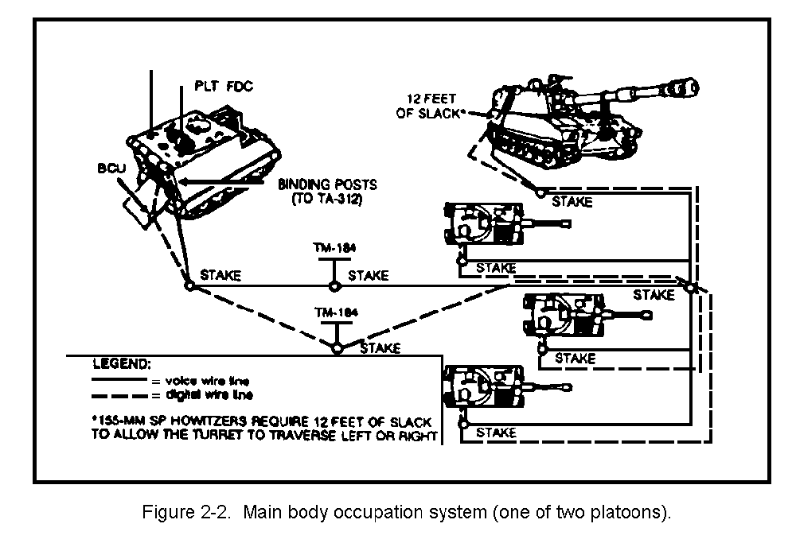
-- Other devices such as horns and alarms should be used in accordance with the unit SOP.

- Check to see that radios are operational and prepared for use if needed.

SUMMARY

The preferred defense against an armored or mechanized attack is for the battery or platoon to move to a position where it can continue the mission. Defense against mechanized forces should concentrate on slowing down the tanks, separating the infantry from the tanks and canalizing tanks into predetermined kill zones.

Concealment is the primary defense against air attack. Warning signals must be known by all battery personnel. These signals must be practiced and should be found in unit SOPs. When attacked, all weapons in the battery are used to return fire. If convoys must move during these times of enemy air superiority they should move by night or by infiltration.

Fight dismounted attacks outside the battery or platoon position. Once the enemy is on the run, chase him with artillery fires. Do not dispatch forces to chase him.

Establishment of a firebase may be necessary in LIC environments. Appendix B (Appendix H, FM 6-50) contains detailed considerations on establishment of firebases.

Against counterfire, dispersion, hardening of positions and movement to alternate positions are the primary defenses.

Continual inspection of the defense posture is essential, and the shifting of resources must be made when a gap in the defense posture is discovered. Attacks against artillery in positions can be expected and must be resisted. The mission of the field artillery is to provide fire support to the maneuver elements. Artillery will not withdraw from a position or fail to render fire support because of a threat of attack by hostile forces except as part of a planned withdrawal and upon receipt of orders from the next higher command. Traditionally, the artillery continues the mission and defends the guns.

Lesson 2

PRACTICE EXERCISE

The following items will test your knowledge of the material covered in this part of the subcourse. There is only one answer for each item. When you have completed the exercise, check your answer with the key that follows. If you answer any item incorrectly, study again that part which contains the portion involved.

1. Threat armored or mechanized attacks are characterized by:

A. Tanks following mechanized forces and firing from standoff positions.
B. Tanks and dismounted infantry attempting to overrun the position while support vehicles fire from standoff.
C. Tanks will try to overrun battery positions while assault vehicles fire from standoff; followed by mounted or dismounted assault.
D. Tanks firing from standoff positions to destroy the battery by fire.

2. The preferred defense against armored or mechanized forces is to:

A. move to alternate positions.
B. separate the infantry from the tanks.
C. slow down the tanks.
D. canalize tanks into pre-determined kill zones.

3. The primary way for a FA battery to defend against possible air attacks is to:

A. conduct rehearsals of warning signals for air attack.
B. all battery small arms are used to fire on targets.
C. have division or corps Stinger or Redeye teams strategically placed.
D. be so well concealed that the enemy cannot acquire the battery.

4. If the battery or platoon is attacked, the key to survival is:

A. dispersion and engagement of the enemy with a large volume of fire.
B. to have division or corps Stinger or Redeye teams strategically placed.
C. to improve concealment.
D. have all small arms return fire.

5. Once attacked by a dismounted enemy, one thing to remember is to:

A. have the reaction force pursue the enemy for not more than 400 meters.
B. insure that there are interlocking fires to the battery or platoon front.
C. fight the enemy outside the position.
D. maintain light and noise discipline.

6. The greatest threat to artillery is:

A. armored or mechanized attacks.
B. counterfire.
C. air attack.
D. NBC attack.

7. What three techniques are used to survive the counterfire threat?

A. Dispersion, hardening of positions, and movement.
B. Dispersion, camouflage and hardening of position.
C. Dispersion, hardening of position and use of terrain.
D. Dispersion, hardening of position, and movement.

8. Guidance for leaders in establishing procedures during NBC attacks is found in:

A. FM 5-103.
B. FM 6-50.
C. FM 3-100.
D. FM 5-50.

9. When checking camouflage, a key item to check is that:

A. natural cover and terrain are used to advantage.
B. artificial camouflage is preferred over natural camouflage.
C. units have arranged terrain and vegetation to suit battery or platoon requirements.
D. artificial camouflage is used to tone down spoil, tracks, and tramplings.

10. When checking weapons emplacements, ensure that:

A. once satisfactory positions are prepared, they are left alone to prevent damaging the camouflage.
B. only crew-served weapons need to have range cards checked by leaders.
C. Minefields are not identified to preclude their use by the enemy.
D. each position has assigned sectors of fire.

PRACTICE EXERCISE 2

ANSWER KEY AND FEEDBACK

ITEM Correct Answer and Feedback

1. C. Tanks will try to overrun battery positions while assault vehicles fire from standoff; followed by mounted or dismounted assault.

If an enemy armored or mechanized force detects the battery or its platoons, the enemy can be expected to take the following actions:

(1) Tanks will try to overrun the firing battery positions.

(2) Assault vehicles will fire antitank guided missiles, 73-mm guns, and machine guns from standoff positions. (para 1a).

2. A. move to alternate positions.

Friendly response to attack. The preferred defense against an armored or mechanized ground attack is for the battery or platoon to avoid direct engagement and move to alternate positions in order to continue the fire support mission. (para 1b).

3. D. be so well concealed that the enemy cannot acquire the battery.

The primary way for an FA battery to survive when the enemy has air parity or superiority is to be so well concealed that the enemy cannot acquire the battery. (para 2a).

4. A. dispersion and engagement of the enemy with a large volume of fire.

If the battery is detected and attacked, the key to survival is dispersion and engaging attacking aircraft with a large volume of fire. (para 2a).

5. C. fight the enemy outside the position.

A properly equipped 10-man enemy patrol can neutralize a cannon battery that is lax in defensive planning or execution. To prevent this, the battery must fight the enemy outside the position and ensure fighting positions provide interlocking sectors of fire around the position. (para 3).

6. B. counterfire.

Counterfire continues to be the greatest threat facing the artillery. Dispersion, hardening, and movement are techniques used to survive the counterfire threat; but those techniques should not be used in isolation.(para 5).

7. D. Dispersion, hardening of position, and movement.

See feedback to question 6. (para 5).

8. C. FM 3-100.

The BC must ensure that unit SOPs give procedures for dealing with NBC attacks. SOPs should cover protective measures, immediate action, decontamination and reporting. Guidance for the commander is in FM 3-100. (para 6).

9. A. natural cover and terrain are used to advantage.

Insure all of the measures taken to conceal the platoon location from the enemy continue to be taken. These include the following:

- Natural cover and terrain are used to advantage.
- Sections operate without disturbing the surroundings.
- Personnel continue to practice dispersion and receive on-the-spot corrections for each and every camouflage violation. . etc. (para 1).

10. D. each position has assigned sectors of fire.

One of the checks of a defensive position is to see that each position has assigned sectors of fire that overlap the positions to their flanks, and stakes are emplaced to indicate the lateral limits. (para 2).

LESSON 3

CAMOUFLAGE PRINCIPLES AND TECHNIQUES

Critical Task: 01-2660.01-0052
061-226-4016

OVERVIEW

LESSON DESCRIPTION

In this lesson you will learn about enemy observation including vehicle and artillery-revealing factors and techniques for camouflage of section positions and equipment.

TERMINAL LEARNING OBJECTIVE

ACTION: Camouflage the battery or platoon position.

CONDITION: Given the material contained in this lesson.

STANDARD: Correctly answer all questions in this lesson.

References: This lesson is based on FM 5-20, and other materials approved for US Army Field Artillery School instruction. However, development and progress render the text subject to change. Therefore, base your examination answers on material presented in this text rather than on individual or unit experience.

INTRODUCTION

To camouflage means to disguise or hide. The word "camouflage" also described actions taken to mislead or misrepresent then true identity of an object or activity. Camouflage, as an element of military deception, enables us to remain hidden within striking distance of the enemy.

PART A - PRINCIPLES OF CONCEALMENT

1. Overcoming the six recognition factors.

Lesson 1 described the six recognition factors of position, color, shape, shadow, texture, and movement. The three principles of concealment are used to counter the six factors of recognition. The three basic principles of concealment are:

a. Principle 1: Siting equipment.

- Properly site electronic equipment to reduce signature. Site all equipment to eliminate exposure and the possibility of detection. Figure 3-1 shows an example of proper siting and dispersal of tents in sparsely vegetated (barren) terrain.

- Use terrain and natural concealment.

- Make use of all camouflage. Put your vehicles in places that keep them hidden. Trees or shrubs can hide units. Built-up areas are great for hiding equipment because, in that environment, man-made items look like other man-made items and do not contrast with "natural" surroundings. Desert sands or winter snow can be used to hide equipment.
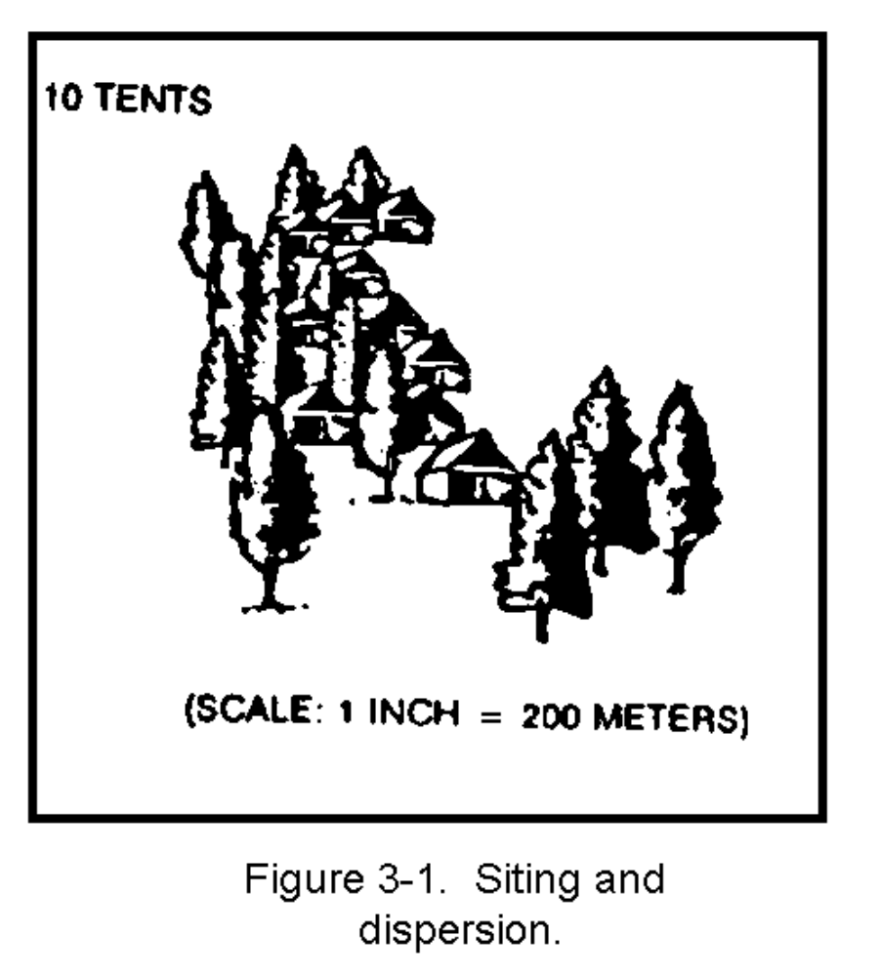

- Use whatever is available in the area in which you operate.

b. Principle 2: Construct camouflage. After the equipment is sited, the LWSS should be erected immediately to cover the piece of equipment and the working (or crew) area.

- Use camouflage material that matches the surroundings. For example, do not use oak branches from the last position that do not match the pine trees in the new position.

- Do not break up natural up and down living tree patterns with man-made patterns (lines). When using cut foliage to camouflage equipment, it should be replaced as soon as it starts to wither. Withered foliage surrounded by living trees and shrubs is an obvious giveaway to your position.

c. Principle 3: Camouflage discipline. Camouflage discipline (Figure 3-2) is the avoidance of any activity that may alter the natural appearance of an area or indicate the presence of military equipment or activity.

- Establish, enforce, and maintain camouflage, light, and noise discipline. Carelessness or failure to maintain camouflage discipline ruins the whole camouflage effort.

- Enforce light and noise discipline continuously.
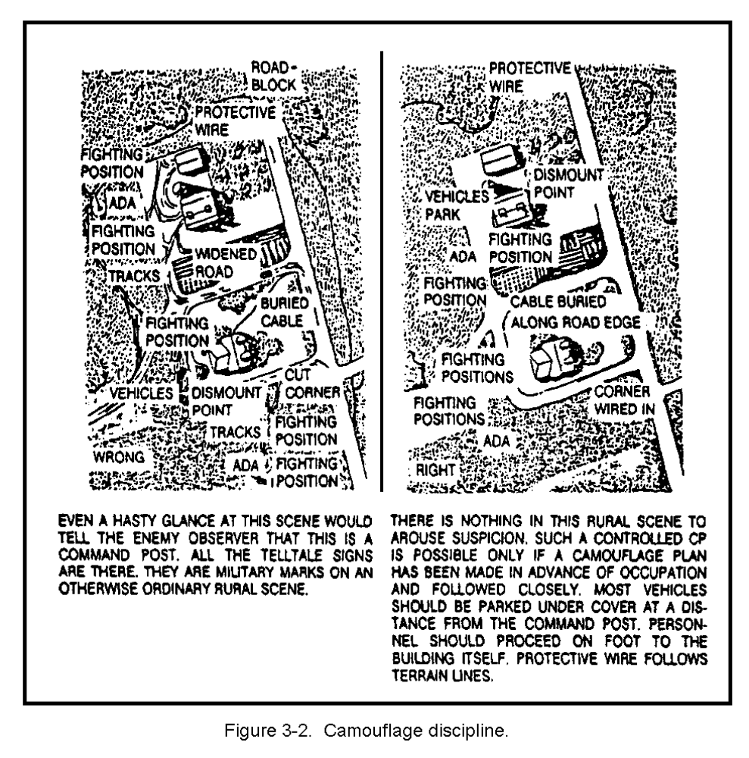
d. After you think everything is well sited and well camouflaged, step back and closely study the camouflage area. If you see anything that looks unnatural or if the six factors of recognition have not been eliminated, the enemy will see the same thing.

2. Camouflage methods. There are three fundamental methods of camouflaging installations and activities--hiding, blending, and deceiving. Of the three camouflage methods, hiding and blending are most often used by the field artillery. Deceiving is a very effective method but rarely used because of extensive manpower and equipment requirements.

a. Hiding. Hiding is the complete concealment of an object by some type of physical screen. This screen may or may not be visible to the enemy, but it keeps the enemy from recognizing the hidden object.

b. Blending. Man-made objects have symmetrical, geometric outlines that are easily recognized. Blending is the arrangement of camouflage materials on, over, and around an object so that man-made objects appear to be part of the natural background. The objective of blending is to prevent detection of the equipment by a change in the natural appearance of the position.

c. Deceiving. Deceiving is the use of camouflage or an activity to simulate an object, situation, or other activity. Deception misleads the enemy as to the identity, strength, intention, or activity of our forces. It causes him to divide his attack, and it draws his fire away from essential targets. Well planned and cleverly executed decoys are among the most effective ways to deceive the enemy. For example, a decoy pillbox (Figure 3-3) constructed of wood, covered with burlap or canvas, and sprayed with paint and sprinkled with sand to resemble concrete is sure to deceive the average observer into believing it to be the real thing. Deception is not limited to visual decoys. Other types, such as electromagnetic transmitter (EMT) decoys, simulate the radio and radar transmissions of a unit and produce the same result: drawing the observer's fire away from our essential facilities.
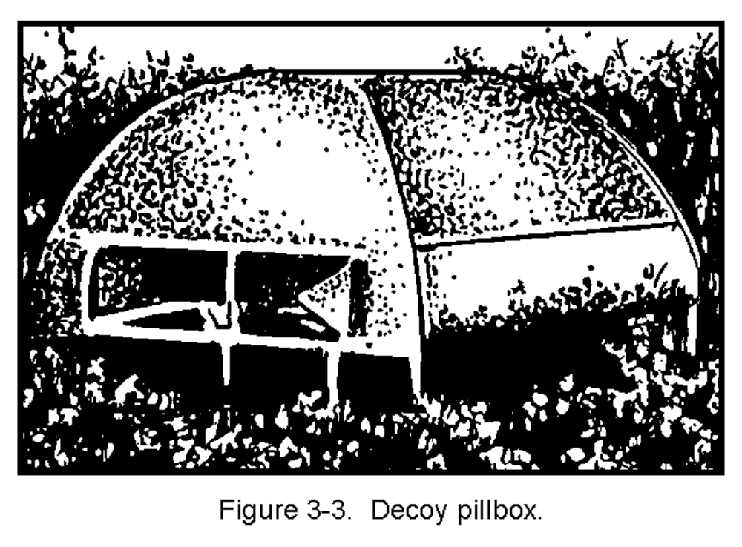
PART B - INDIVIDUAL CAMOUFLAGE

Individual camouflage consists of steps a soldier uses in combat to make himself invisible to the enemy. He must know how to use his environment and adapt his dress to blend with this background. He must carefully select his routes between positions to gain as much concealment as possible while he is in motion. These simple principles have been battle tested. If the soldier learns and continuously practices them in training, he knows what to do in actual battle.

1. Camouflage considerations.

a. Types of enemy observation. Individual camouflage activities are designed to deceive two kinds of enemy observers--ground and aerial. Views from the ground are familiar, but views from the air are usually quite unfamiliar. In modern warfare, the enemy puts much reliance on aerial photographs for information as to our activities and intentions. It is important to become familiar with the bird's-eye view of the terrain as well as the ground view in order to learn how to guard against both kinds of observation.

b. Use of background. Effective concealment of the individual depends primarily on the choice of background and its proper use. Background is the surrounding area seen from the ground or air. It may be anything--a portion of the jungle; an area in a barren, rocky desert; a farmyard; or a city street. It is the controlling element in individual camouflage and governs every concealment measure. The clothing worn must blend with the predominant color of the background. Skin and light colored equipment are toned down for the same purpose. The individual soldier must practice blending with the background by hiding in shadows and avoiding contrast between his silhouette and the background. He must avoid movement that the immobile background emphasizes. To keep the appearance of the background free of signs that point to the presence of military personnel and activities, he must follow hidden routes and conceal spoil, tracks, equipment, and installations.

2. Individual Camouflage Techniques.

a. Tone down the skin. Face, neck, and hands should be toned down by painting them in a disruptive pattern or in an even color (Figure 3-4). When disruptive painting is used, the patterns should cut across the nose lines, cheekbones, eye sockets, and chin lines. Burnt cork and mud can be used or, in absence of natural materials, the face paint stick may be used. A mesh mosquito netting, properly toned down, is an effective way of breaking up the outlines of the face.

b. Disguise the helmet. The outline of the helmet is one of the striking characteristics of a soldier's equipment. Its familiar shape can be easily identified by the enemy. One of the first steps for individual camouflage is the disruption of the form of the helmet and the shadow it casts. There are several ways to accomplish this (Figure 3-5). Improvised helmet covers can be made from circular pieces of burlap or other cloth 20 inches in diameter. A 1-inch hem is sewn around the edges, a drawstring is pulled through it, and the whole cover is pulled tightly onto the helmet. Discarded sandbags, because of their appropriate size, make excellent improvised covers. The covers, regardless of their fabric, should be painted to break up the solid color. Two-inch slits are cut into the cover to allow for insertion of foliage or boughs. No matter what kind of helmet camouflage is used, it is incomplete if the shadow beneath the helmet is not broken up by arranging a bit of foliage or garnishing to hang over the rim of the helmet. Small irregular pieces of cloth, similarly arranged, accomplish the same effect. Remember, age and repeated washings fade equipment. When this occurs, it must be darkened with paint, mud, charcoal, or anything that reduces the total contrast.
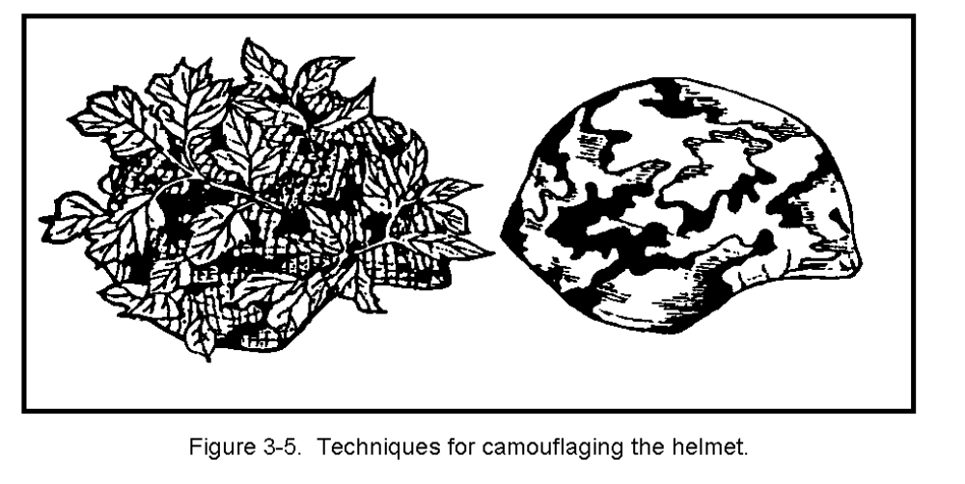
c. Tone down weapons. One of the simplest ways to distort the give-away outline of a weapon is by wrapping it with burlap garnishing or strips of cloth dyed to match the background. Pattern painting the weapon is another excellent method of distorting the weapon outline. The shiny parts can be covered by cloth, paint, or mud. When camouflaging a weapon, care must be taken not to cause interference with weapon sighting and firing (Figure 3-6).

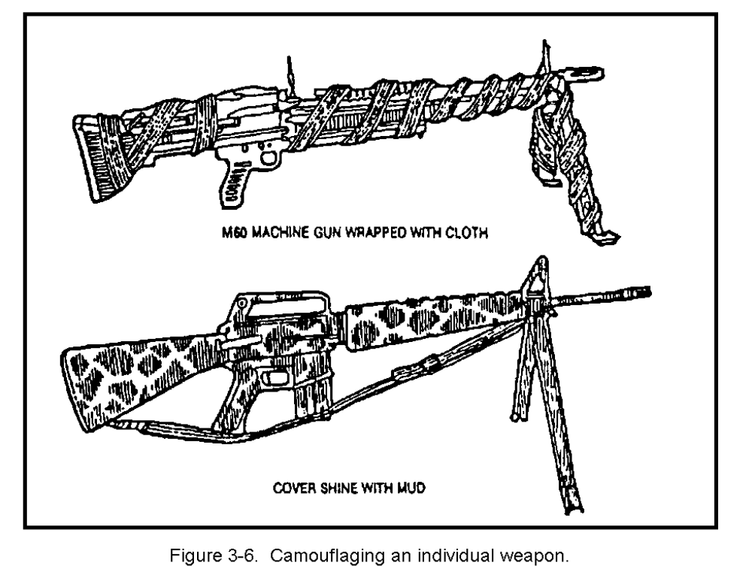
d. Tone down shiny objects. Reflection from brightly shining objects is a common breach of camouflage discipline. All shiny objects must be concealed--including such items as watches, rings, belt buckles, and mess kit items. A violation that must be avoided is wearing goggles on the helmet.

e. Camouflage clothing. The modern battle dress uniform (BDU) comes in colors and patterns that adapt to the various terrain environments. Most common are the forest pattern and the desert pattern BDU. The important thing about the BDU is that, in the field, it looks less like a uniform and more like the terrain on which it is worn (Figure 3-7). White garments designed to blend with a white or mottled white and black background are available for use in snow-covered terrain. The snowsuit does not conceal the small patches of shadow surrounding a human figure. However, this is not necessary, since snow country is seldom all white—it contains numerous dark spots and shadows. If certain snow areas are all white with absolutely no shadows, use is made of defiles, snowdrifts, and natural folds in the ground.

However, camouflaging the skin and helmet, using BDUs, and covering shiny objects are only a part of completing individual concealment. Depending completely on a camouflaged uniform and disregarding other elements of camouflage can lead to disastrous results.

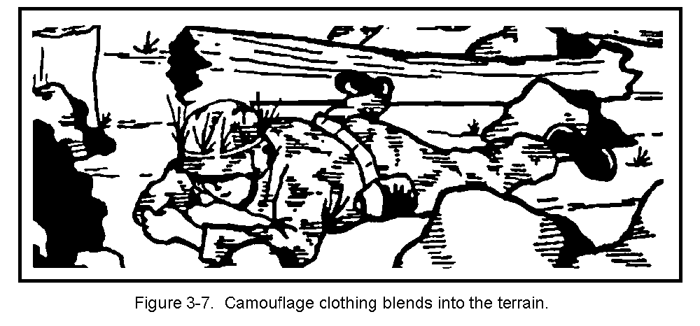

NOTE: Though the enemy may be able to see the position, camouflage is still used to prevent him from recognizing what it really is. Even if the enemy can recognize the position, camouflage is used to prevent him from estimating how large the installation is and how many troops it shelters.

f. Practice dispersion. Dispersion as a means of camouflage must be a key word for the individual soldier's action. By nature, the human is gregarious or group oriented. When under the stress of combat, this natural trait becomes exaggerated. The response to this inborn trait is to bunch or come together in small knots and clusters. That is why, during training of recruits in simulated battle exercises, training officers and noncommissioned officers constantly exhort their men, "Scatter out--don't bunch up,". Remember, dispersion - accomplishes two things:

- Prevents men and material from becoming targets.

- Makes the men and material more difficult to see.

The governing factors in dispersion are the tactical situation, the nature of the terrain, and the control of troops.

PART C - CAMOUFLAGE OF SECTION POSITIONS AND EQUIPMENT

To be able to direct and enforce camouflaging of section positions and equipment, one must fully understand camouflage methods, know the materials used in camouflaging, and know how and when these natural or artificial materials are applied. We must know how the shape of the object is used to blend in with its surroundings. In addition, altering the color or texture of vehicles and equipment, removing the tracks made by those vehicles moving into position, and digging in vehicles in barren or open terrain must be considered.

1. Vehicle-revealing factors

A poorly concealed vehicle (Figure 3-8) can lead to much more than just a destroyed vehicle. It may mean discovery of a unit, disclosure of an important tactical plan, or complete destruction of an installation. Camouflage of vehicles depends not only on concealing the vehicle shine, shadow, and shape but also on preventing and concealing its tracks.

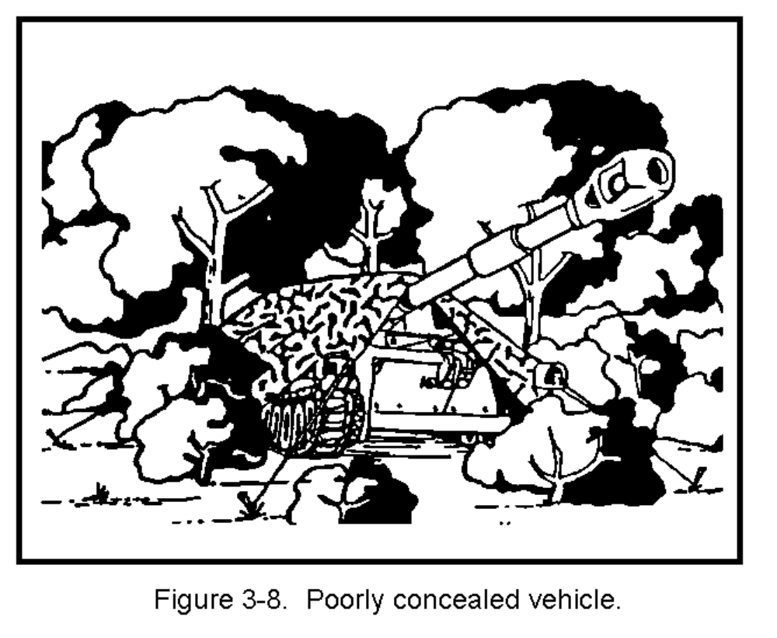
a. Tracks. Tracks are especially revealing to the aerial observer. They indicate type, location, strength, and even intentions of a unit. The gradual turns of wheeled vehicles are distinguishable from the skidding turns of a track-laying vehicle. Often, a single track across an area of low vegetation is completely visible. Tracks should follow closely and be parallel to hedges, fences, cultivated fields, and other natural terrain lines in order to remain inconspicuous from the air.

- Overhead cover of a given road should be used, and existing gaps should be filled either with artificial or natural materials. On short stretches, exposed tracks can be erased by brushing leaves and debris over them. All concealed routes should be marked before use. Guards should be posted to ensure minimum disturbance in the area.

- The unit, through camouflage training, must ensure that all personnel are trained to follow terrain patterns and use all overhead cover when possible. Particular attention must be directed to the training of vehicle drivers. They must follow the camouflage rules automatically. Figure 3-9 shows the effects of ignoring (wrong) and of following (right) proper track concealing procedure.

b. Shine. Site and track discipline do much to conceal a vehicle, but shine can nullify the best site and finest track discipline. Shine is caused by a windshield, headlight, cab window, wet vehicle body, or even by the light paint of the insignia. Even under heavy overhead cover, shiny objects may be revealed through the smallest gaps.
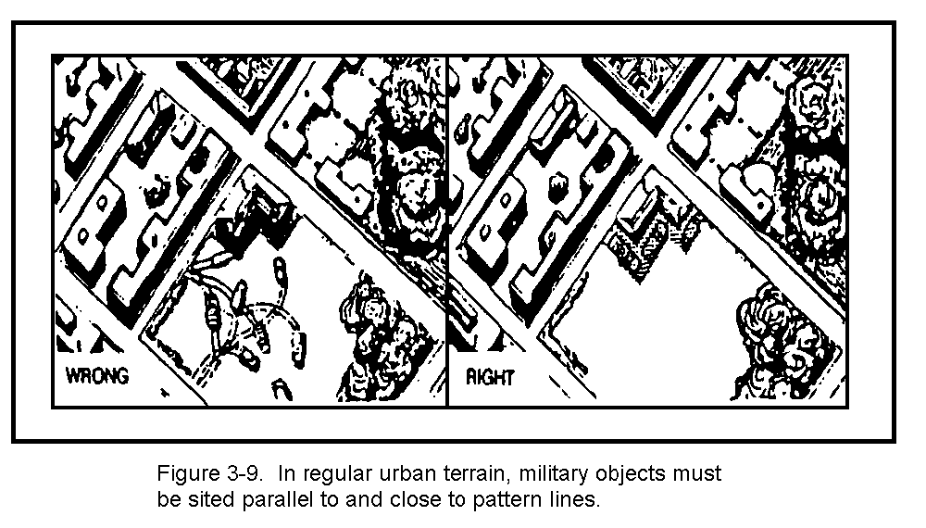
- Equipment Shadow. There are two kinds of shadows to consider in camouflage. One is the concealing shadow. From the air, these appear so dark that a vehicle parked within them has a good chance of remaining undetected. The other kind of a shadow to consider is that cast by whatever you are trying to hide. In the case of a truck, for example, this revealing shadow must be hidden by parking either in the shadow of a larger object or on the sunny side of the object. In addition, the shadow line of a truck body in and around the cab, beneath the fenders, within the wheels, and in the open back of the cargo space must be blocked out for they, too, facilitate identification. A very distinctive shadow that artillery units must deal with is that of the aiming circle on a tripod. It is a sure giveaway of a unit's location to a Threat observer or photo analyst. It is important to remember that, in many cases, the object itself may not be seen by the observer (on an aerial photograph), but the shadow cast by the object may be so unique that positive identification of your equipment can be made.

2. Vehicle Camouflage Measures

Camouflage measures vary with the situation and are affected by the following:

a. Sitting and dispersion. As is always the case in camouflage, the aim of good vehicle sitting is to occupy the terrain without altering its appearance. To do this, vehicles should be parked under natural cover whenever it is available. When cover is inadequate, vehicles should be parked so that the shape of the vehicle blends into the surroundings.

b. Natural materials. While good sitting and dispersal are essential, sometimes they are not enough. Greater concealment can be accomplished by supplementing these measures with natural materials to break up the shape and shadows of vehicles (Figure 3-10). This material is usually available near a parking site and can be erected and removed quickly. When cut foliage is used, it should be replaced as soon as it starts to wither. Altering the color of vehicles and adding texture to them are other ways to supplement sitting and dispersion. Color may be changed by applying mud to the body and tarpaulin. Texture may be added all over or in patterns by attaching leaves, heavy grass, or coarse sand to the surface with an adhesive.

NOTE: When using cut foliage to supplement your camouflage, do not cut in the immediate position area. This will still give your position away since the stumps left by such cutting can be detected by Threat observers.
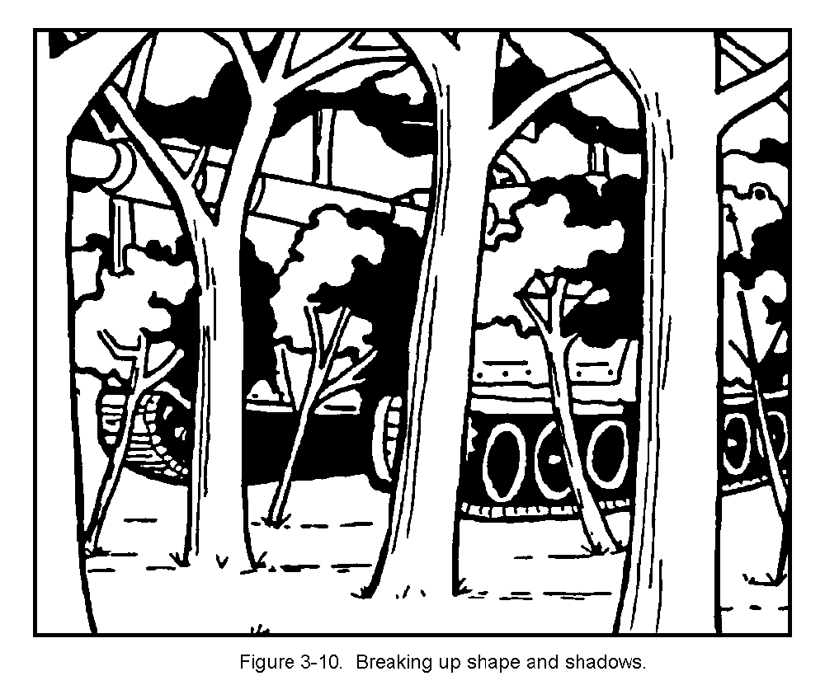
c. Lightweight screening systems. The most common artificial material used to conceal vehicles is the lightweight camouflage screening system (LWSS). Consisting of a combination of modules, the LWSS is easy to use. Lightweight screening systems can provide complete concealment from direct observation, especially when supplemented with natural materials. However, as with most artificial camouflage materials, it can frequently be detected by photographic observation if it fails to blend properly with the background. Nevertheless, when properly suspended and supported, the LWSS conceals the identity of a vehicle or activity. The screen modules of the LWSS are fastened together and are designed to cover vehicles and weapons (to include the working area). The modules are held together by pins fastened to a cord. The pins are inserted into clips (Figure 3-11). When correctly assembled, they form a slit, providing a means of quickly opening the net for fire missions. These screens provide both a screening and a blending capability, preventing detection by observation and color photography.

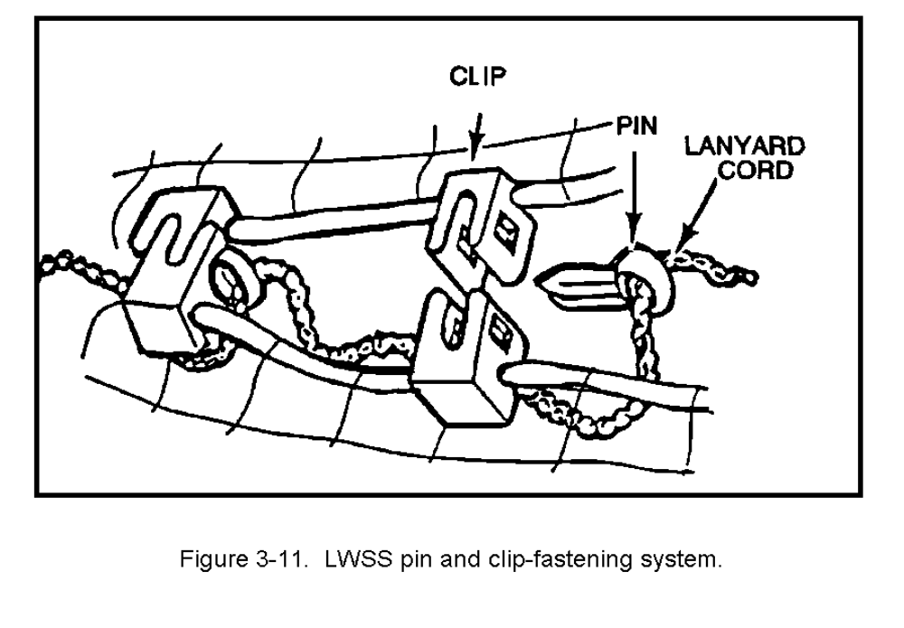
In addition, the garnishing material is chemically impregnated to prevent detection by infrared and camouflage-type photography. One module of the LWSS (Figure 3-12) is comprised of one hex screen and one diamond screen. The quantity of modules required to fully camouflage a vehicle, weapon, or other object depends on its size and is listed in the unit TOE/MTOE.

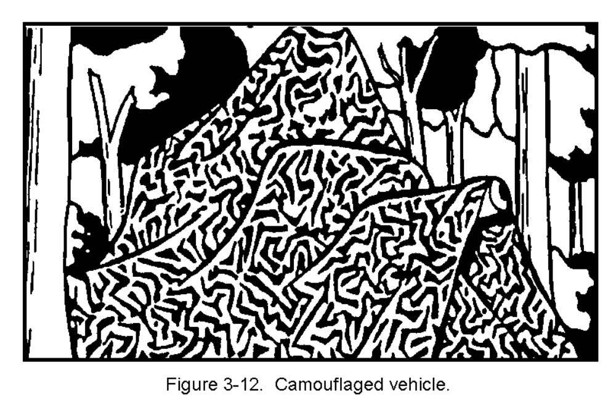
d. Pattern painting. As noted earlier, all military vehicles and equipment have characteristic shapes and exterior shadows. These "signatures" contrast with natural surroundings and make the object conspicuous. Pattern painting (Figure 3-13) does much to break up signature characteristics by using lusterless paint to reduce the glare of smooth surfaces; color to reduce contrasts with the soil and vegetation predominant in a given region; and pattern shape, size, and placement to distort the vehicle form. The paint also reflects near infrared radiation. The patterns, designed for each type of vehicle, have color areas that cut off corners; avoid straight vertical and horizontal lines; and extend shadows in shapes similar to natural features and vegetation. Pattern painting makes the item much harder to recognize as a military object and provides an excellent base for further, more complete camouflage. If properly sited, the pattern-painted vehicle needs less work to camouflage than a solid-colored vehicle.

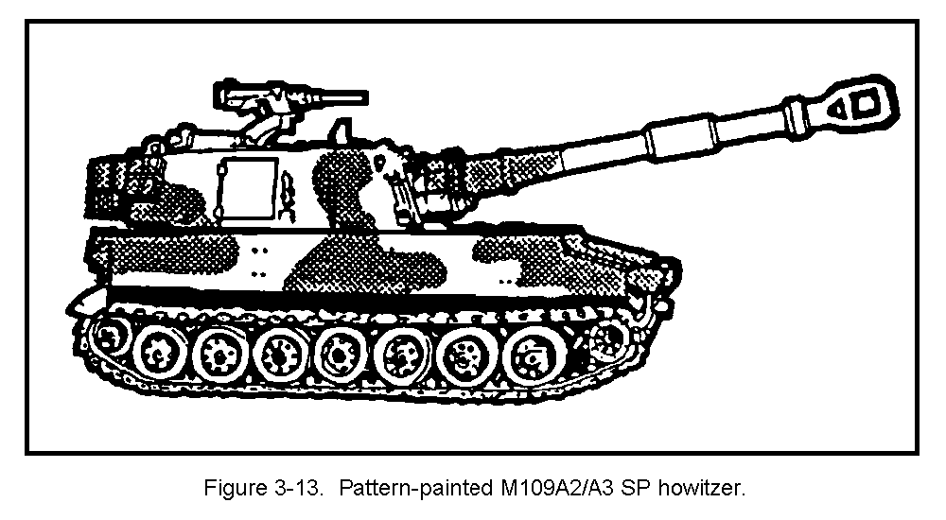
e. Digging in. In a desert, or any open barren terrain, the lower an object is to the ground, the smaller its shadow. This makes it easier to conceal from aerial observation. When the situation permits, every effort must be made to dig-in important vehicles. Not only are they more easily concealed, but they are also protected from fragments. An excavation is made with a slanting approach and the vehicle is parked in a pit. Sandbags are used to form a revetment for protection, and the whole emplacement is covered with a net. The net is sloped gently out to the sides and staked down. Finally, the vehicle tracks to the position are brushed out or covered.

PART D - REDUCING ARTILLERY RECOGNITION FACTORS

Enemy observers are trained to search for certain signs that indicate artillery positions, such as blast areas, litter, paths or wheel tracks and the scars in the terrain pattern. Even though the weapons themselves are hidden, such signs are dead giveaways of the presence of artillery. These signs may not indicate the exact nature of the position, but they do attract enemy attention and invite more careful observation.

1. Consideration for vehicle camouflage.

a. Situational factors. As with vehicles, artillery camouflage measures vary with the situation and are affected by the following:

(1) There is little opportunity to camouflage positions extensively for short duration occupancy.

(2) When FA units are deployed for a coordinated attack, the location of each platoon and howitzer should be carefully selected.

(3) In a defensive action, extensive camouflage is developed. Utmost precaution must be taken to deceive the enemy concerning the location of the installation.

b. Siting. The exact position for the elements of a platoon within the assigned area must possess several qualifications:

(1) Provide required field of fire.

(2) Allow sufficient room for weapons, vehicles, and other equipment organic to the platoon.

(3) Offer opportunity to establish communications without creating attention-getting ground scars and paths.

(4) Provide access and supply routes. It is desirable to have routes available to the front, flanks and rear. This is important in situations where it may be necessary to make sudden changes in position; for example, where it becomes necessary to move and occupy the alternate position.

c. LWSS. Whenever natural concealment is impossible or difficult, suitable camouflage can be accomplished by using the LWSS as discussed in PART C. The design of the LWSS makes it adaptable for use in nearly all types of terrain, but it is particularly useful for concealing weapons in barren or desert areas where natural aids to concealment are unavailable.

d. Digging in. As with vehicles in a desert or open barren terrain, artillery weapons (when dug in) offer a smaller target. The lower an object, the smaller its shadow, making it easier to conceal. The addition of camouflage materials to cover the dug-in position gives a greater amount of concealment. Track marks and spoil that are left uncovered must be removed or obliterated. Although assets may be scarce, engineer equipment can be helpful in digging in a vehicle or a weapon position. An experienced dozer operator can provide a suitable position, either dug in or bermed up. Such a position should be long enough to permit the M548 cargo carrier or the field artillery ammunition support vehicle (FAASV) to occupy the same position. Figure 3-14 illustrates a dug-in position for an M109A2/A3 SP howitzer.
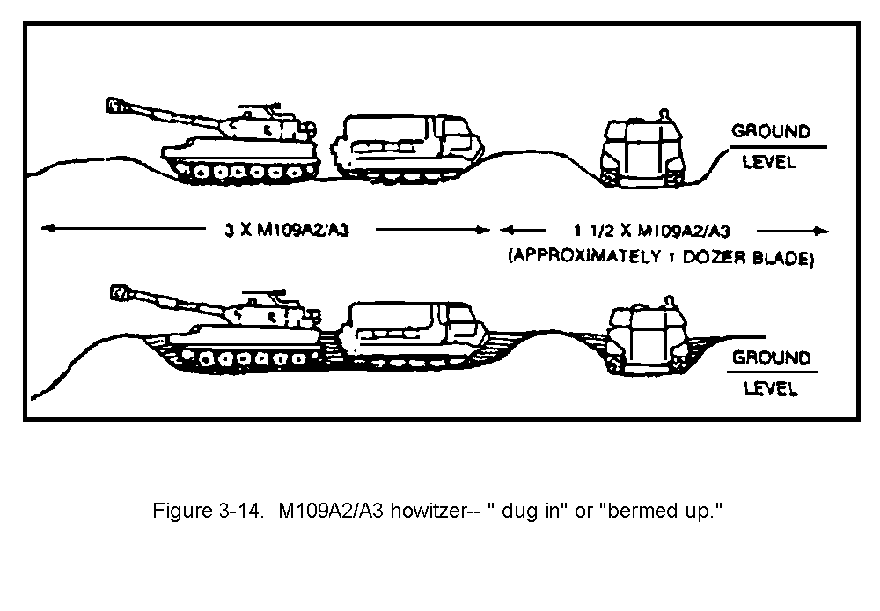

2. Light and Noise Discipline.

The enforcement of light and noise discipline plays an important part in the accomplishment of the mission. The need for light discipline during daylight hours is limited. Noise discipline during daylight hours must be considered so the noise does not disrupt unit communications activities or rise above the noise level tolerance for the situation. Therefore, our concern is largely toward the enforcement of light and noise discipline during the hours of darkness.

a. Light discipline. By far the most important phase of night discipline is light discipline. Any advantage the enemy is given will be used to neutralize or destroy friendly units. The following are considerations for good light discipline:

- Necessary work lights are shielded on vehicles and at bunkers, weapons, ammunition dumps, dining facilities, or any other position.

- Lighting of matches or smoking outdoors is prohibited at all times.

- Those lights not being used indoors (tents, APCs) should be shielded to prevent glare or reflection.

- Night lighting devices, such as flashlights and field-expedient lights, are filtered to prevent light from being seen at great distances.

- Night-lighting devices on aiming posts, aiming circles, collimators, and all other on- and off-carriage fire control equipment are in operating condition so that unauthorized lighting equipment will not be used to illuminate them.

- Light discipline is observed and confusion is avoided by spelling out in the unit SOP the means of individual position identification. One way of doing this is the color-coding of aiming post night light filters. For example, all even-numbered weapons have red filters on the near aiming post lights and green on the far aiming post lights. Odd-numbered weapons have the opposite aiming post lights. The aiming circle is identified in some way to distinguish it from other lights in the area. For example, the lay circle may be identified by a red filtered cone flashlight and the safety circle may be identified by green. In addition, the SOP must spell out how to communicate with lights during the hours of darkness (visual signals). Lights should always be turned off when not in use. A good unit SOP helps eliminate confusion.

b. Noise discipline. Noise discipline is always important. More so at night when noise carries farther because of atmospheric conditions. It is difficult enough to operate in darkness with drastically reduced visibility without the added distraction and confusion created by excessive noise. More important, sound also gives the enemy clues to friendly locations and the type of unit he faces. It must be realized that a certain amount of noise is generated in the course of normal operations. However, the amount of noise must be controlled by implementing and enforcing the following preventive measures:

- Loud orders, talking, calling, and sneezing—even whispering should be kept to a minimum under certain circumstances.

- Only essential movement of vehicles should be permitted. The noise from an engine, gears, or movement of wheels or tracks on some surfaces can be heard at long distances. Move vehicles only during firing, if possible.

- Individual equipment should be padded and fastened to prevent banging noises.

- Loading and unloading vehicles should be done silently. Each piece of equipment must be lifted carefully and set down noiselessly.

- Under certain critical conditions, it may become necessary to disconnect vehicle horns. Of course, all engines must be turned off at the earliest practical time commensurate with operational necessity.

NOTE: The unit SOP includes the measures taken in noise discipline, as well as light discipline, as previously described.

SUMMARY

Camouflage describes the actions taken to mislead the enemy by disguising or misrepresenting the true identity of an individual, an installation, an activity, or an item of equipment.

Individual camouflage conceals the soldier from ground and aerial observation by deceiving and outwitting the enemy. Complete, effective concealment takes proper account of prevailing terrain and background conditions. Close attention is devoted to disrupting the shape and shadow of objects such as helmets, weapons, and associated equipment. Toning down reflections from skin and shining metal objects (weapons, mess kits, watches, belt buckles) is accomplished by the resourceful use of both natural and artificial materials.

Dispersion is critical on the battlefield. Leaders must enforce dispersion for both its camouflage value and the reduced possibility of casualties from enemy fires. Nevertheless, the final responsibility for effective camouflage measures taken on the battlefield rests squarely on the shoulders of the individual soldier, because his life is at stake.

Directing and enforcing camouflage of section positions, vehicles, and equipment includes knowledge of methods, such as knowing when and how to use natural and artificial materials, how the shape of the object is used to blend with its background, and how the color or texture of a vehicle and tracks made by the vehicle affect camouflage. The correct measures taken in camouflage prevent detection by the enemy.

Enforcement of light and noise discipline includes those measures taken to prevent friendly forces from being seen or heard. Shielding work lights, prohibiting the lighting of matches or smoking outdoors, covering unused lights, and filtering and color coding by SOP to prevent confusion are measures taken to enforce light discipline. Measures taken to enforce noise discipline include padding equipment, limiting vehicle movement to periods of firing, and avoiding loud orders, talking, or calling.

LESSON 3

PRACTICE EXERCISE

The following items will test your grasp of the material covered in this lesson. There is only one correct answer for each item. When you complete the exercise, check your answer with the answer key that follows. If you answer any item incorrectly, study again that part of the lesson which contains the portion involved.

1. One objective of camouflage is to prevent:

A. recognition.
B. attacks.
C. deception.
D. concealment.

2. The purpose of deceptive camouflage (deceiving) is to:

A. provide total concealment.
B. create a cloak of invisibility.
C. draw enemy fire away from real targets.
D. prevent detection.

3. Proper siting reduces the affects of:

A. of position, shape, and movement.
B. color, shape and shadow.
C. all of the above.
D. none of the above

4. The arrangement of camouflage materials on, over, and around an object so that it appears to be part of the background is known as:

A. hiding.
B. blending.
C. deception.
D. siting.

5. In constructing camouflage using the blending method, great care must be taken to avoid:

A. cutting underbrush.
B. geometric designs.
C. using artificial camouflage materials.
D. patterns that present shadows.

6. The complete concealment of an object or installation is accomplished by:

A. deception.
B. siting.
C. hiding.
D. simulation.

7. The basic kinds of enemy observers are:

A. long range patrols and spies.
B. high altitude imagery and remotely piloted vehicles
C. human and mechanical (i.e., satellites, drones, etc.)
D. ground and aerial.

8. The controlling element in individual camouflage is:

A. blending.
B. background.
C. hiding.
D. shape.

9. Two items that can be used to improvise a helmet cover are:

A. burlap, sandbags (or other cloth).
B. branches and leaves.
C. foliage or boughs.
D. small irregular pieces of cloth.

10. In the disruption step of camouflaging the helmet, the two things that must be disrupted are:

A. shadow and texture.
B. shape and shadow.
C. shape and color.
D. color and shadow.

11. Three parts of the body that require toning down by painting are:

A. Arms, face and hands
B. Face, neck and arms.
C. face, neck, hands.
D. none of the above.

12. Camouflage of a vehicle depends on concealing:

A. the vehicle, its shape, shine and shadow.
B. the vehicle, its shape, shine, shadow and tracks.
C. and preventing its tracks.
D. A and C only
E. B and C only

13. Tracks are especially revealing to:

A. partisans.
B. enemy intelligence analysts.
C. the aerial observer.
D. the ground observer.

- Two kinds of shadows to consider in camouflage are:

A. natural shadow cast by objects like trees and hills and artificial shadows cast by buildings and vehicles.
B. stationary and moving shadows.
C. opaque shadows cast by buildings and translucent such as those cast by a LWSS.
D. concealing shadow and that cast by what you are trying to hide

15. As with vehicles, artillery camouflage measures vary with the:

A. situation.
B. extent of damage to the environment.
C. availability of camouflage materials.
B. B and C only.

16. The LWSS is particularly useful in:

A. concealing personnel in highly forested terrain.
B. concealing weapons in barren or desert terrain.
C. both A and B.
D. none of the above.

17. Besides offering protection from line-of-sight weapons, digging in of vehicles:

A. allows for construction of overhead cover for howitzers.
B. lowers the object, thus reducing the size of its shadow, making it easier to conceal.
C. is not a good concealment method since it creates a large amount of spoil that must be camouflaged.
D. A and B only.

LESSON 3

PRACTICE EXERCISE

ANSWER KEY AND FEEDBACK

Item Correct Answer and Feedback

1. A. recognition.

Lesson 1 described the six recognition factors of position, color, shape, shadow, texture, and movement. The three principles of concealment are used to counter the six factors of recognition.(para 1).

2. C. draw enemy fire away from real targets.

Deceiving is the use of camouflage or an activity to simulate an object, situation, or other activity. Deception misleads the enemy as to the identity, strength, intention, or activity of our forces. It causes him to divide his attack, and it draws his fire away from essential targets. (para 2c).

3. C. all of the above.

The referenced paragraphs discuss how sitting reduces the effects of the six recognition factors. (para 1 and 1a).

4. B. blending.

Blending is the arrangement of camouflage materials on, over, and around an object so that man-made objects appear to be part of the natural background. The objective of blending is to prevent detection of the equipment by a change in the natural appearance of the position. (para 2b).

5. B. geometric designs.

Man-made objects have symmetrical, geometric outlines that are easily recognized. The objective of blending is to prevent a change in the natural appearance of the position. (para 2b).

6. C. hiding.

Hiding is the complete concealment of an object by some type of physical screen. (para 2a).

7. D. ground and aerial.

Types of enemy observation. Individual camouflage activities are designed to deceive two kinds of enemy observers--ground and aerial. (para 1a).

8. B. background.

Effective concealment of the individual depends primarily on the choice of background and its proper use. It is the controlling element in individual camouflage and governs every concealment measure. (para 1b).

9. A. burlap, sandbags (or other cloth).

Improvised helmet covers can be made from circular pieces of burlap or other cloth 20 inches in diameter. (para 2b).

10. B. shape and shadow.

The outline of the helmet is one of the striking characteristics of a soldier's equipment. Its familiar shape can be easily identified by the enemy. One of the first steps for individual camouflage is the disruption of the form of the helmet and the shadow it casts. (para 2b).

11. C. face, neck, hands.

Tone down the skin. Face, neck, and hands should be toned down by painting them in a disruptive pattern or in an even color. (para 2a).

12. E. B and C only.

Camouflage of vehicles depends not only on concealing the vehicle shine, shadow, and shape but also on preventing and concealing its tracks. (para 1).

13. C. the aerial observer.

Tracks. Tracks are especially revealing to the aerial observer. They indicate type, location, strength, and even intentions of a unit. (para 1a).

14. D. concealing shadow and that cast by what you are trying to hide.

Equipment Shadow. There are two kinds of shadows to consider in camouflage. One is the concealing shadow. From the air, these appear so dark that a vehicle parked within them has a good chance of remaining undetected. The other kind of a shadow to consider is that cast by whatever you are trying to hide. (para 1c).

15. A. situation.

Situational factors. As with vehicles, artillery camouflage measures vary with the situation. (para 1).

16. B. concealing weapons in barren or desert terrain.

Whenever natural concealment is impossible or difficult, suitable camouflage can be accomplished by using the LWSS as discussed in PART C. The design of the LWSS makes it adaptable for use in nearly all types of terrain, but it is particularly useful for concealing weapons in barren or desert areas where natural aids to concealment are unavailable. (para 1c).

17. B. lowers the object, thus reducing the size of its shadow, making it easier to conceal.

As with vehicles in a desert or open barren terrain, artillery weapons (when dug in) offer a smaller target. The lower an object, the smaller its shadow, making it easier to conceal. (para 1d).

LESSON 4

FIELD FORTIFICATIONS

Critical Task: 01-2660.01-0052
061-266-4016

OVERVIEW

LESSON DESCRIPTION

Upon completion of this lesson, you will be able to identify different types of individual and weapons fighting positions the techniques and principles governing their construction to include the designation of fields of fire.

TERMINAL LEARNING OBJECTIVE

ACTION: Identify properly constructed individual defense positions.

CONDITION: Given the material contained in this lesson.

STANDARD: Correctly answer all questions in the practice exercise at the end of this lesson

References: This lesson is based on FM 5-103, The Field Artillery Cannon Battery, and other materials approved for US Army Field Artillery School instruction. However, development and progress render the text continually subject to change. Therefore, base your examination answers on material presented in this text rather than on individual or unit experience.

INTRODUCTION

The individual defensive position is an indispensable part of the FA battery or platoon defense plan. It is important to remember that immediate action is taken by every member of the platoon to improve the position and implement the defense plan according to SOP. This includes individual defensive positions, particularly if a hostile counterfire threat exists. These actions and the implementation of the defense plan do not await the BC's or platoon leader's final approval. Rather, it is an ongoing task throughout the battery while a position is occupied. As part of the platoon defense plan, each section is assigned an area or a sector of responsibility for the defense. The section chief—on the basis of the information provided, the special characteristics of the terrain, and the weapons available within the section--designates the physical location of the individual defense positions for his section and ensures their proper and speedy construction. The section chief also must consider the location for supplementary defensive positions, as required. Individual defensive positions and supplementary positions are selected for their natural defensive strength and the observation and fields of fire afforded. Construction measures include clearing fields of fire, digging individual positions, strengthening natural obstacles, installing artificial obstacles and early warning devices (see Appendix B), and applying maximum feasible camouflage and concealment. Construction must be progressively developed; that is, proceeding from an open to a covered emplacement and shelter to the ultimate protection permissible under the existing circumstances.

PART A - TYPES OF EMPLACEMENTS.

1. Hasty emplacements.

Hasty emplacements are dug by troops in contact with the enemy when time and materials are limited. Hasty positions should be supplemented with overhead cover and strengthened as conditions permit. If the situation permits, the chief of section verifies the sectors of observation and fire for the individual members of the section from their designated positions before they dig individual fighting positions. The emplacements described below provide protection against flat trajectory fire. They are used when there is no natural cover. Hasty positions (Figure 4-1, 4-2, and 4-3) are good for a short time because they give some protection from direct fire. If the unit remains in the area, it must be developed into a well-prepared position to provide as much protection as possible.

a. Shell crater (Figure 4-1). A shell or bomb crater of adequate size, 2 to 3 ft wide, offers immediate cover and concealment and can be quickly made into a hasty position. By digging the crater to a steep face on the side toward the enemy, the occupant can provide himself with a firing position. A small crater can later be developed into a fighting position. Craters, even if developed, are susceptible to being overrun by tracked vehicles.
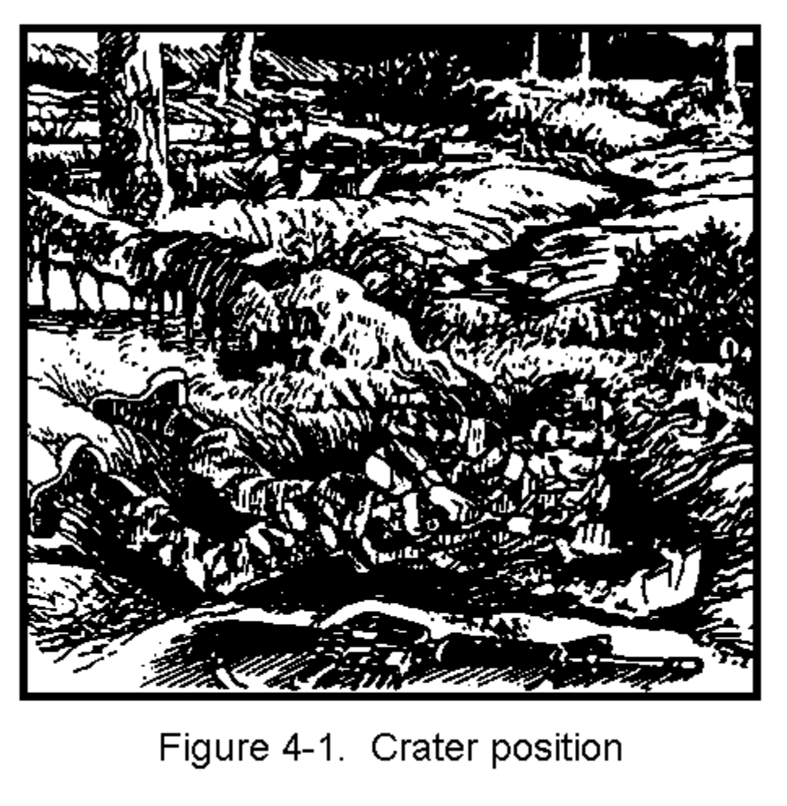
b. Skirmisher's trench (Figure 4-2). The skirmisher’s trench is a shallow pit type emplacement that provides firing position for the individual soldier. It is constructed when immediate shelter from heavy fire is required and no existing firing positions are available. A soldier may construct a skirmisher's trench while he lies prone or on his side. A skirmisher's trench is a low parapet between the soldier and the enemy. The trench should be oriented so that it is least vulnerable to enfilade (raking) fire. In Figure 4-2 a skirmisher's trench, provides a soldier with a low silhouette and is protected to a limited extent from small-arms fire.
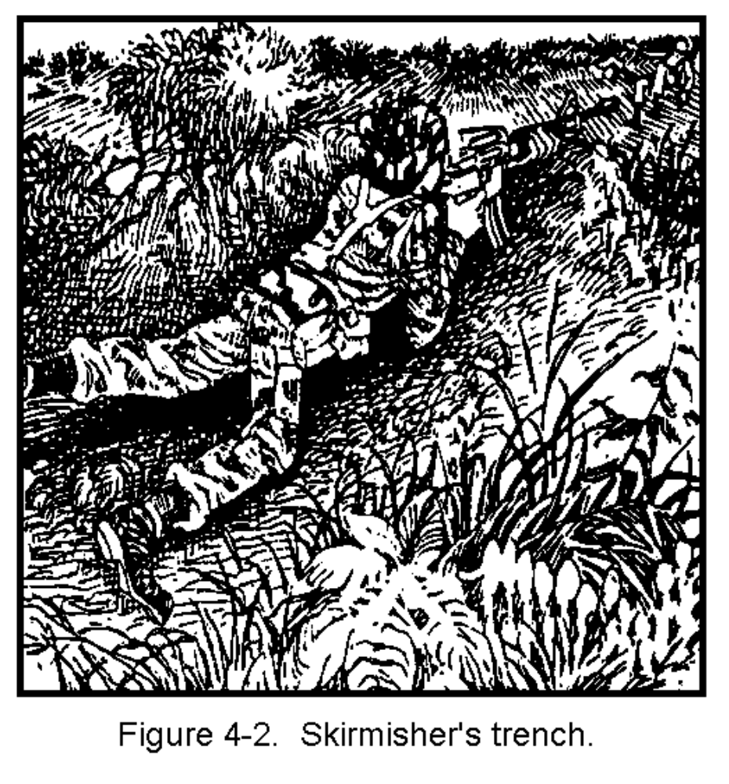
c. Prone emplacement. This emplacement (Figure 4-3) is a further refinement of the skirmisher's trench. The berm dimension of this emplacement, as shown in the parapet detail, is varied to conform to the position and arm length of the occupant. It serves as a good firing position for a rifleman and provides better protection against small arms or direct fire weapons than the improved crater or skirmisher's trench.

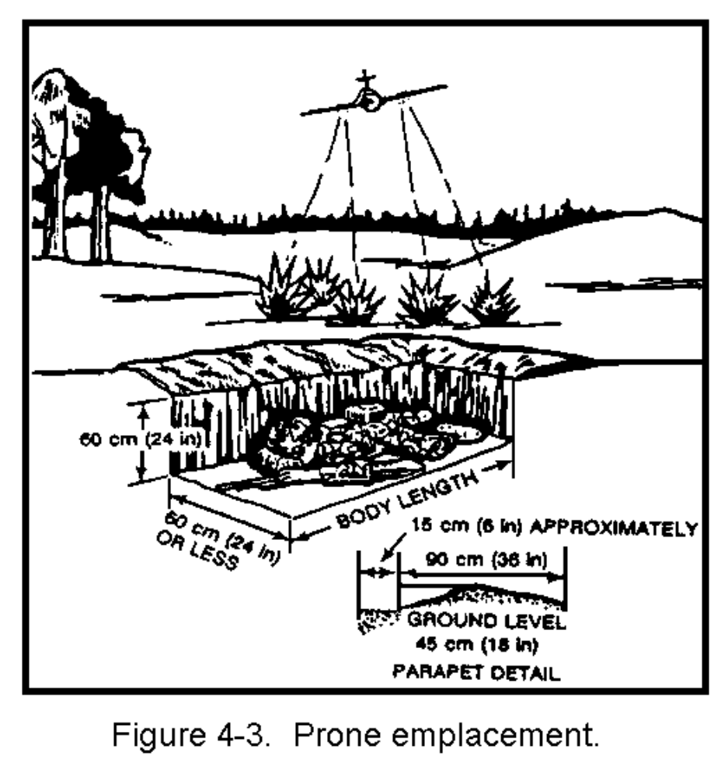
d. Rocks, snow, and ice. Limited protection can be provided by piling up rocks, chunks of ice, or packed snow. Ice crete, formed by mixing dirt and water, is very effective as an arctic building material. A minimum of 30 cm of this material resists penetration of small-arms fire.

2. Fighting Positions.

Fighting positions are the individual rifleman's basic defensive position. They afford good protection against enemy small arms fire and can be developed from well chosen craters, skirmisher's trenches, or prone emplacements. Fighting positions should be improved (as time and materials permit) by revetting the sides, adding expedient cover, providing drainage, and excavating a grenade sump to dispose of hand grenades tossed into the hole by the enemy.

a. One-soldier fighting position. The one-soldier fighting position is the individual soldier's basic defensive position. It allows flexibility in the use of cover, since the hole need only be long enough for one soldier plus gear. It does not have the security of a two-person position; therefore, it must allow a soldier to shoot to the front or oblique from behind frontal cover. Improvements should be made to the position as long as the battery or platoon occupy a position, and consistent with the mission. Improvements include adding overhead cover, digging trenches to adjacent positions, and maintaining camouflage. The overall dimensions and layout of the one-man fighting position are shown in Figure 4-4. However, the time and situation no doubt cause us to use field expedients in obtaining the dimensions. The length of the M16 rifle and bayonet and the height of the individual are appropriate measurements for obtaining the dimensions.

b. Fire step. The fire step is that portion of the fighting position on which the soldier rests his elbows while firing. The depth to the fire step varies depending on the height of a comfortable firing position for the occupant, usually 3 ft to 5 ft, or armpit deep. The occupant, crouched in a sitting position on the fire step, must have at least 60 cm (2 ft) of overhead clearance if a tank overruns the fighting position. This normally provides protection against the crushing action of tanks. However, in loose unstable soil, the walls of the fighting position will have to be revetted to provide this protection.

c. Grenade sump. The grenade sump, is the diameter of the entrenching tool, 18 inches long, and sloped downward. It is excavated at a 30ø angle under the fire step. Hand grenades thrown into the fighting position are exploded in this sump, and their fragmentation is restricted to the unoccupied end of the fighting position.
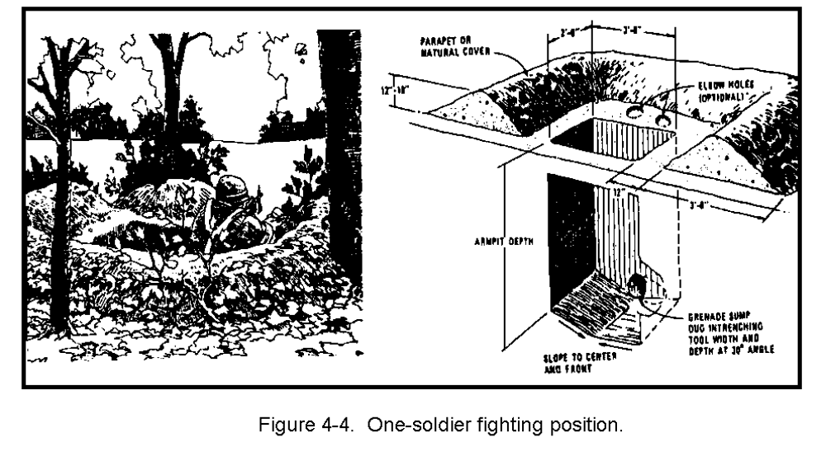
d. Parapet. If excavated soil is used as a parapet (Figure 4-4), it should be placed as a layer about 3 ft wide and 6 inches high all around the fighting position, leaving an elbow rest (berm) of original earth 12 inches wide next to the fighting position. If sod or topsoil is used to camouflage the parapet, the sod or topsoil should be removed from the area, set aside until the parapet is complete, and then placed on top in a natural manner.

e. Camouflage. Whether or not a parapet is constructed in wooded or bushy terrain, a fighting position should be camouflaged effectively with natural materials (Figure 4-4 and 4-5). In open or cultivated areas, it may be preferable to omit the parapet, remove the excavated soil to an inconspicuous place, and improvise a camouflage cover for the fighting position. This can be a light, open frame of branches garnished with grass or other natural foliage to match the surroundings. As an alternative, the fighting position can be covered with a shelter half, poncho, or other expedient material in accordance to local terrain conditions. The occupant raises one side of the cover for observation or firing.

f. Overhead cover. A half cover over a one-man fighting position provides good protection for the occupant and permits full use of the weapon (Figure 4-5). Logs 4 to 6 inches in diameter or 6 inch timbers about 4 ft long will adequately support the earth cover. However, these logs should be long enough to extend at least 1 ft on each side of the fighting position to provide a good bearing surface for the logs supporting the overhead cover (Figure 4-6). Dirt should be removed to each side so that the supporting logs or timbers are even with the ground surface. If the ground is soft and tends to break away, a surface of planks or timbers should be provided for cover supports. Logs or timbers of this size will support an earth cover 1 to 1« ft thick. The walls of the fighting position should be stabilized with revetting material (Figure 4-7) at least under the overhead cover to prevent a cave-in from the added weight of the cover.
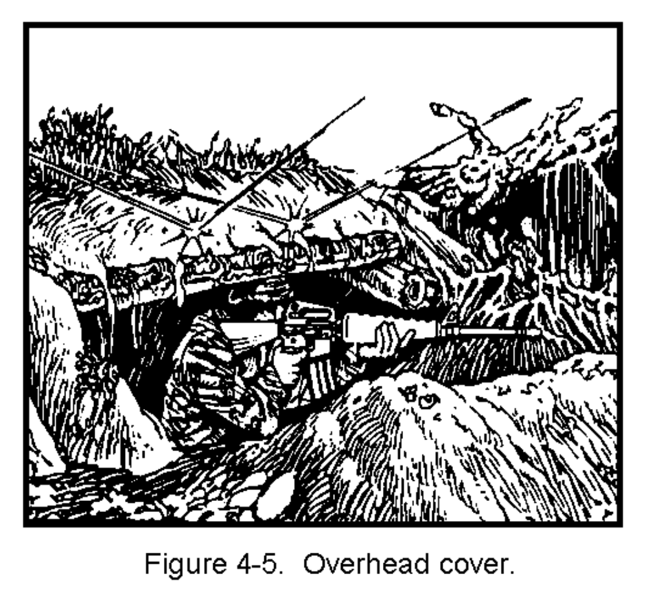
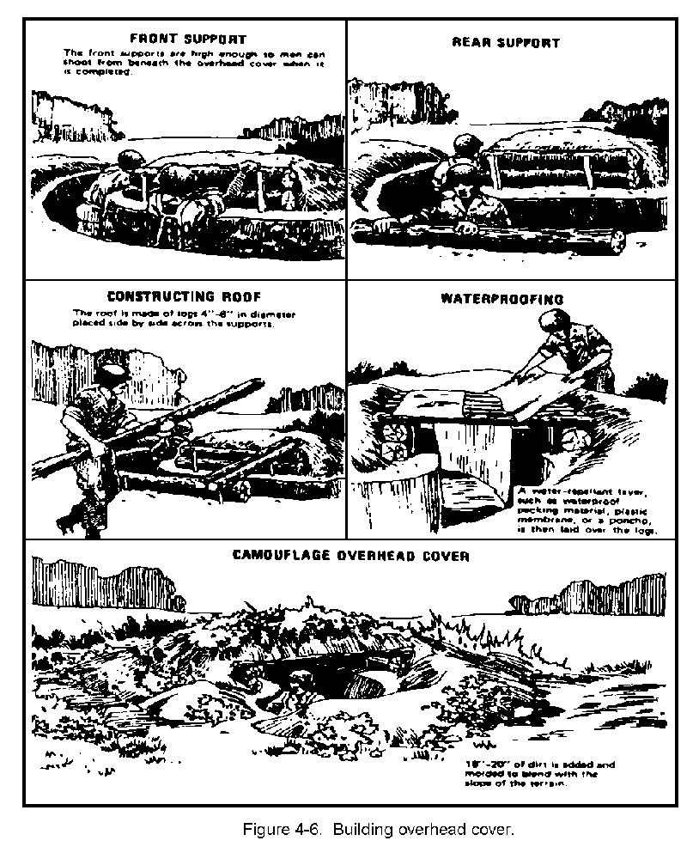
g. Revetment material. Expedient material such as brushwood, saplings, sheet metal or dimensioned (construction) lumber should be thin and tough so that it will support the sides of the emplacement when properly staked and tied. Revetment stakes (A, Figure 4-8), either metal or wood 1.8 meters (6 ft) long, should be spaced not more than 60 cm (2 ft) apart and driven into the ground 30 to 45 cm (B, Figure 4-8). The revetment stakes are held firmly in place by anchor wires (C, Figure 4-8). Five or six strands of 14-gage or barbed wire attached at ground level between the revetment stakes and the anchor stakes are considered adequate to hold the revetment stakes in place. The anchor wires are tightened by twisting them together at ground level. The distance between the revetment and anchor stakes should be approximately twice the depth of the excavation. The wire between the stakes should not pass over the parapet in any case.
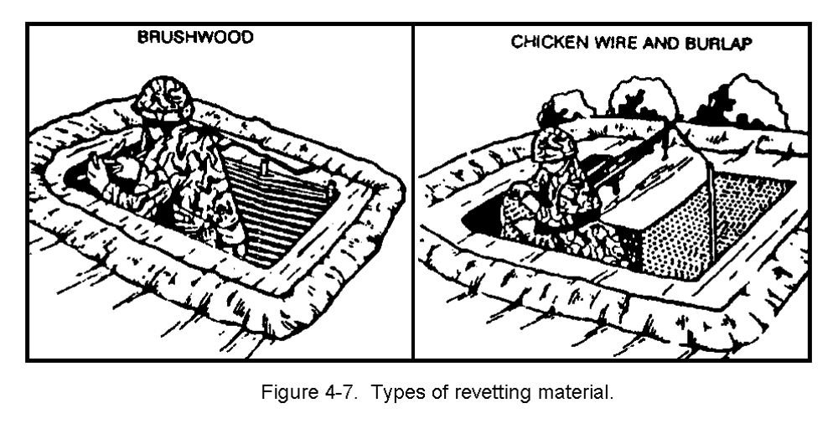
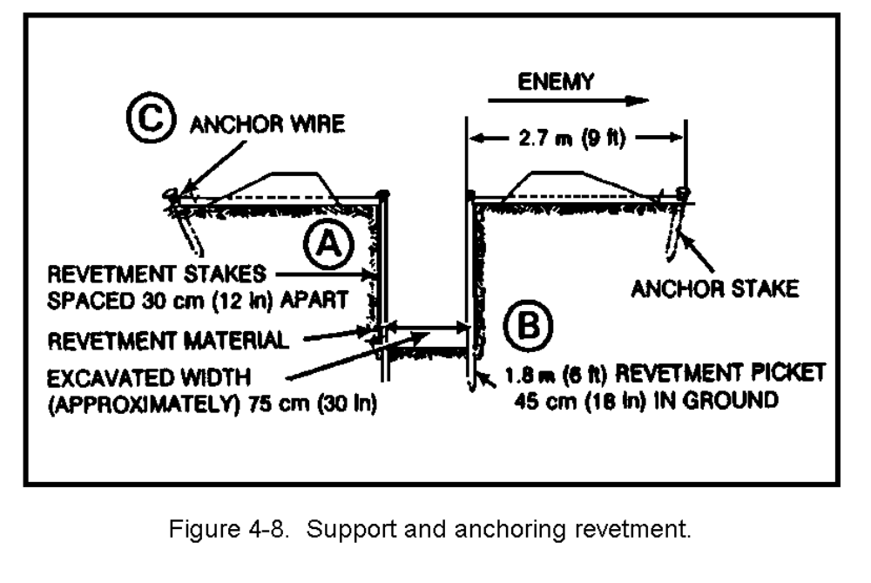
PART B - FIELDS OF FIRE

1. Clearing fields of fire.

a. Principles. There is little opportunity to clear fields of fire when a unit is in contact with the enemy. Individual riflemen and weapon crews must select the best natural positions available. Usually, there is only time to clear areas in the immediate vicinity of the position. However, in preparing for expected contact with the enemy, suitable fields of fire are cleared in front of each fighting position. Following are some important points to remember.

(1) Excessive or careless clearing discloses firing-position locations (Figure 4-9) to enemy observers.

(2) In areas organized for close defense, clearing should start near the position and work forward at least 100 meters (328 ft) or to the maximum effective range of the weapon, if time permits.

(3) A thin natural screen of vegetation should be left to hide defensive positions.
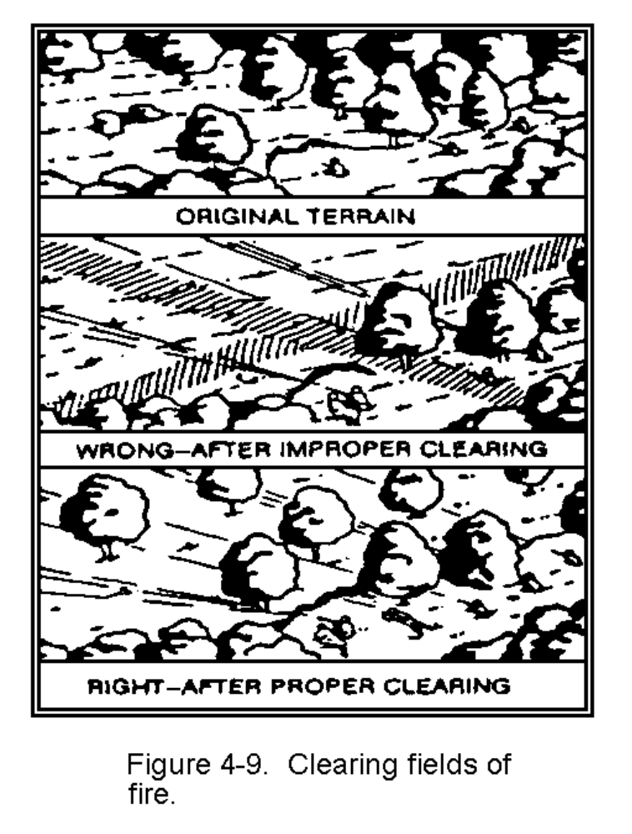
b. Procedure

(1) Remove the lower branches of large scattered trees in sparsely wooded areas.

(2) In heavy woods, cutting fields of fire may be neither possible nor desirable within the time available. Restrict work to thinning the undergrowth and removing the lower branches of large trees. Clear narrow lanes of fire (Figure 4-10) for automatic weapons.
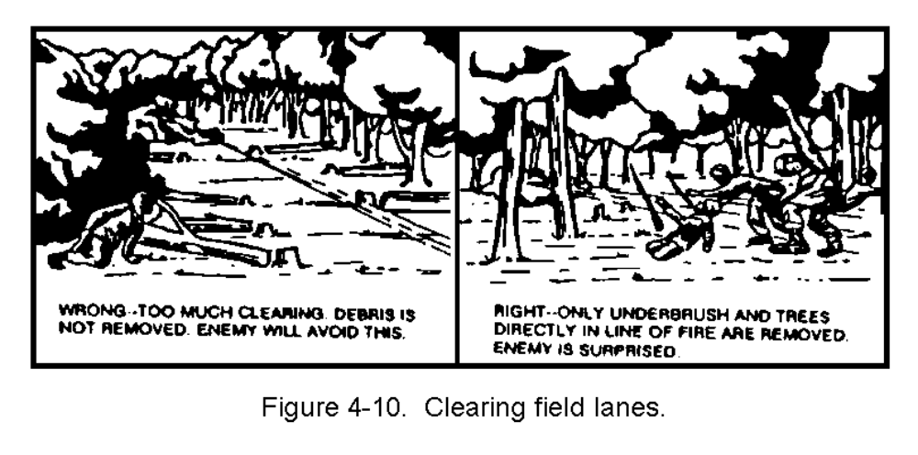
(3) Thin or remove dense brush, since it is never a suitable obstacle and it obstructs the field of fire.

(4) Cut weeds when they obstruct the view from firing positions.

(5) Remove cut brush, weeds, and limbs to areas where they cannot be used to conceal enemy movements or disclose the friendly position.

(6) Do only a limited amount of clearing at one time. Overestimating the capabilities of the unit in this respect may result in a field of fire improperly cleared. This would afford the enemy better concealment and cover than the natural state.

(7) Cut or burn grain, hay, and tall weeds.

(8) Whenever possible, check the position from the enemy side to be sure that the position is effectively camouflaged and that it is not revealed by clearing fields of fire.

SUMMARY

Individual defensive positions must be carefully selected for their natural defensive strengths; constructed properly to afford maximum protection, camouflage, and fields of fire; and improved continually to maintain an adequate defensive posture. Construction materials are seldom provided. Tools beyond those organic in a section are often in short supply, and time available for extensive construction of individual positions is usually critical. Thus, full emphasis is placed on ingenuity, resourcefulness, and the techniques discussed in this lesson to develop viable defenses when your section is ordered to dig in.
The correct application of these construction guidelines results in effective protection for each individual and contributes materially to the effectiveness of the overall defense plan. The platoon defense must be well planned and vigorously executed if the platoon is to accomplish its mission of providing fire support without incurring friendly losses because of Threat attacks.

LESSON 4

PRACTICE EXERCISE

The following items will test your grasp of the material covered in this lesson. There is only one correct answer for each item. When you complete the exercise, check your answer with the answer key that follows. If you answer any item incorrectly, study again that part of the lesson which contains the portion involved.

1. A _____________ is a shallow pit type emplacement that provides a temporary, open, prone firing position.

A. shell crater
B. skirmisher's trench
C. prone trench
D. kneeling trench

2. While sitting in the crouched position in a one man fighting position, the occupant must have at least _____ of overhead clearance.

A. 2 ft.
B. 3 ft.
C. 4 ft.
D. 5 ft.

3. A grenade sump must be dug at a 30ø angle and to a depth of ______ inches.

A. 6
B. 10
C. 15
D. 18

4. A parapet is built using the excavated soil that is placed as a layer about 3 feet wide and ______ inches high.

A. 8
B. 10
C. 12
D. 14

5. When establishing the depth to the fire step, a good rule of thumb is to dig it ________ deep.

A. armpit
B. knee
C. shoulder
D. chest

6. When clearing a field of fire in areas organized for close defense, clearing should start near the position and work forward ______ meters.

A. 50
B. 75
C. 100
D. 150

LESSON 4

PRACTICE EXERCISE

ANSWER KEY AND FEEDBACK

Item Correct Answer and Feedback.

1. B. skirmisher's trench.

The skirmisher's trench is a shallow pit type emplacement that provides a temporary, open, prone firing position for the individual soldier. (para 1b).

2. A. 2 feet

The occupant, crouched in a sitting position on the fire step, must have at least 60 cm (2 ft) of overhead clearance. (para 2b).

3. D. 18

The grenade sump, is the diameter of the entrenching tool, 18 inches long, and sloped downward. (para 2c).

4. C. 12

If excavated soil is used as a parapet, it should be placed as a layer about 3 feet wide and 6 inches high all around the fighting position. (para 2d).

5. A. armpit

The depth to the fire step varies depending on the height of comfortable firing position for the occupant, usually 3 feet to 5 feet, or armpit deep. (para 2b).

6. C. 100

In areas organized for close defense, clearing should start near the position and work forward at least 100 meters or to the maximum effective range of the weapon (if time permits). [para 1a.(2)].

